1. Leaving the table unnoticed: extinctions of mountain yellow-legged frogs have weak effects on resources and competitors in their communities
2. Weak interactions between algae, mayflies, and tadpoles suggest communities respond weakly to mountain yellow-legged frog extinctions.
3. Herbivory and competitive effects of mountain yellow-legged frog tadpoles: extinctions may have weak effects on communities

Thomas C. Smith†, Marina Bozinovic, Yishen Miao, Cherie J. Briggs

Department of Ecology, Evolution, and Marine Biology, University of California, Santa Barbara, California 93106 USA; phone: (805) 893-2888

†email: thomas.smith@lifesci.ucsb.edu

Author Contributions: Thomas C. Smith conceived the study, performed the research and analysis, and wrote the manuscript; Marina Bozinovic and Yishen Miao contributed to the research, analysis, and text, and edited the manuscript; Cherie J. Briggs contributed to study design, data analysis, and edited the manuscript.

Abstract

Worldwide declines of amphibian populations and loss of amphibian biodiversity have prompted investigations into the ecological functions of amphibian species and the consequences of their extinctions. In the Sierra Nevada of California, mountain yellow-legged frogs are nearly extinct, yet their interactions with other species remain largely unquantified. We performed two experiments, both of which quantified top-down control of algae by tadpole grazing and to quantify competition between tadpoles and mayflies. In field enclosures in two remote high elevation lakes, we manipulated the densities of tadpoles and mayfly nymphs in a response surface design. Increasing mayfly abundance reduced algal abundance. However, in this experiment, there was no indication that inter- or intraspecific competition negatively affected tadpoles, to the contrary, increasing tadpole abundance may have facilitated individual tadpole growth. Mayflies experienced negative effects of both interspecific and intraspecific competition, as they declined in individual size as densities of both consumers increased. To test the effects of consumers on algal abundance independent of within-lake variability, we performed a separate mesocosm experiment to manipulate the presence and absence of high densities of tadpoles and mayflies. In this experiment, tadpole presence reduced algal abundance by about 50%, but did not reduce algal growth rate. Facilitation by tadpoles may have allowed mayflies to reduce algal abundance. Overall, our studies indicate that the removal of mountain yellow-legged frog tadpoles can allow benthic producers to reach higher abundance and may both harm and help other grazers ; however the magnitudes of top-down and directions of within-trophic level interactions varied within and between our two experiments. The effects of frog and tadpole declines or extinctions appear to be context-dependent and may be difficult to detect..

Keywords: *Ameletus spp,* amphibian declines, *Callibaetis ferrugineus*, interspecific competition, *Rana muscosa, Rana sierrae,* response surface design, Sierra Nevada, top-down control

Introduction

Despite a quarter-century of awareness of worldwide amphibian population declines and extinctions (Stuart et al. 2004, Wake and Vredenburg 2008), the ecological consequences of these declines remain largely unquantified (but see Connelly et al. 2014 and others). Generally, extinctions or species removals can alter communities, in part through the loss of top-down resource control (Hairston et al. 1960, Paine 1966, Carpenter et al. 1985, Chalcraft and Resetarits 2003, Gruner et al. 2008) or through the loss of indirect effects on competitors (Holbrook and Schmitt 1995). Declines and extinctions of amphibians have the potential to change communities, but the magnitude of those changes is likely to vary among species and among communities (Menge 2003. ). However, the extent to which species shape their communities via resource consumption can vary with species identity, so the effects of extinctions are also likely to vary idiosyncratically (Menge 2003).

The importance of a species in a community arises partially from its function as a consumer (Kareiva and Levin 2003). The degree to whicha species affects its resource may depend on several components: the extent to which its resources are subject to top-down control (Shurin et al. 2002, Borer et al. 2005, Wollrab et al. 2012), the extent to which the species can reduce resource abundance, and the extent to which other species share and depend on resources (Murdoch et al. 2003). These characteristics probably vary greatly among species and communities, and certainly do so even within the class Amphibia (Duellman and Trueb 1994, Alford 1999) and the communities to which amphibians belong. Therefore, predictions about the ecological effects of decline or extinction amphibian (or any species) should be based on quantitative measurements of its unique interactions and effects on its community (Simberloff 2003).

The effects of amphibian declines on freshwater and terrestrial communities are likely to depend on the ecological characteristics of the declining taxa. While over 40% of the 5700 amphibian species are declining in either abundance or distribution or both (Stuart et al. 2004),declines of anurans – the frogs and toads – are the best understood and may be the most extensive. Many have declined in abundance or been driven extinct by habitat destruction, over-exploitation, disease, or a combination of causes (Stuart et al. 2004). Anurans, and especially their tadpoles, can be ecologically important in their respective communities (Alford 1999). Many tadpoles are benthic grazers, and reduce the abundance of benthic producers (Kupferberg 1997a, 1997b, Alford 1999, Connelly et al. 2008, 2014). Tadpoles can reduce algal abundance up to -98% in experiments (Brönmark et al. 1991, Lamberti et al. 1992), and can facilitate changes in natural stream community composition by reducing algal abundance (Kupferberg 1997a). This ability to control resources also allows tadpoles to be strong exploitative competitors, and they can induce declines in abundance, growth, and fecundity of other amphibian, insect, and invertebrate grazers (Brönmark et al. 1991, Kupferberg 1997a, 1997b). As consumers, tadpoles can also interfere with feeding by other amphibians (Steinwascher 1978) and by aquatic insects (Kiffney and Richardson 2001), can be negatively affected by interspecific competition (Morin et al. 1988) and can also facilitate other grazers by uncovering grazable benthic material through bioturbation (Ranvestel et al. 2004).

Like many tadpoles, those of the endangered Mountain yellow-legged frogs (*Rana muscosa* and *R. sierrae*) of California’s Sierra Nevada mountains are grazers of benthic algae, and are potential competitors with mayfly nymphs, caddisfly larvae, diptera larvae, and other benthic macroinvertebrates (Grinnell and Storer 1924, Zweifel 1955, Finlay and Vredenburg 2007). These tadpoles may also have been ecologically important because of their historical ubiquity and abundance (Grinnell and Storer 1924), and while abundance alone is not indicative of a species’ importance, it can be just as well correlated with importance as harder to measure species variables (Doak 2003). In lakes along both sides of the Sierra Nevada mountains and in streams in the Transverse Ranges of southern California (Vredenburg et al. 2007), tadpoles once reached densities at which they could occupy an entire lake shoreline (Roland A. Knapp, personal communication). It is now rare to find such robust populations.

Mountain yellow-legged frogs and tadpoles initially declined in distribution and abundance due to predation by stocked non-native trout (Knapp and Matthews 2000). Despite the cessation of stocking, populations continue to be threatened by the emergence and spread of the amphibian chytrid fungus, *Batrachochytrium dendrobatidis* (Briggs et al. 2005). Now, large populations are limited to a handful of extremely high elevation lakes in Yosemite and Sequoia/Kings Canyon National Parks and the adjacent John Muir Wilderness in the southern Sierra. In most lakes in the Sierra Nevada, mountain yellow-legged frogs and their tadpoles have gone locally extinct (Briggs et al. 2010, Vredenburg et al. 2010).

To explore how declines and local extinctions of mountain yellow-legged frogs might affect Sierra Nevada lake communities, we quantified tadpoles’ impacts on their resources and on potential competitors. Mountain yellow-legged frogs tadpoles ingest algae. Tadpoles may compete with insect grazers, and we chose to study mayfly nymphs as potential competitors with tadpoles because they and can also suppress algal abundance (Hill and Knight 1987, Morin et al. 1988, Dudley 1992, Hertonsson et al. 2007) . We predicted that in the presence of tadpoles – representing the pristine, fish and disease free state - algal abundance would be lowest, and that reducing tadpole abundance or presence – mimicking disease driven extinctions - would increase algal abundance. In addition, we predicted that mayflies would reduce algal abundance, and tadpoles and mayflies together would additively reduce algal abundance. We also predicted that average body sizes of each consumer would decline along with increasing consumer densities. To investigate these predictions, we performed two experiments which manipulated the presence or abundance of tadpoles in simplified communities. The results of these experiments clarify the role of mountain yellow-legged frog tadpoles in Sierra Nevada lakes, and shed light on how their extinctions might affect lake communities.

Methods

Experimental methods

We performed two experiments, an *in situ* field experiment and a mesocosm experiment. Our field experiment allowed us to describe, within the natural setting of two remote high elevation lakes, the interactions between two consumers: mountain yellow-legged frog tadpoles (*Rana muscosa* and *Rana sierrae*) and mayfly nymphs (Ephemeroptera, *Callibaetis ferrugineus* and *Ameletus edmundsi*), and their shared resource, benthic organic matter. This consists largely of diatoms but can also include green algae, cyanobacteria, chrysophytes, detritus, bacteria and other microbes; because of the dominance of diatoms and producers, we refer to it hereafter as algae. In the follow-up mesocosm experiment, we tested the effects of two of the same grazers (*Rana sierrae* and *Callibaetis ferrugineus*) on algal resources, in artificial habitats which eliminated the natural nutrient, temperature, and substrate heterogeneity found within most lakes.

*Field enclosure experiment. –* In the field enclosure experiment, we used a response surface design to characterize the independent and interactive effects of grazers. Response surface designs facilitate description of intra- and interspecific interactions, as they allow two factors to vary alone and together (Inouye 2001). For each of our two consumers, we established four consumer abundance levelsabundance. The highest abundance treatments were set by the highest density of each two consumers we have observed in previous amphibian surveys and invertebrate community surveys (Roland A. Knapp, personal communication, and Smith 2015); lower densities were established at half and 1/10 of this high abundance. We also established treatments with absence of each consumer. Thus, tadpole abundance levels were 0, 2, 10, and 20 individuals, while mayfly abundance levels were 0, 25, 125, and 250 individual mayflies. We fully crossed these four abundance levels of the two consumers, was and replicated each of the 16 treatments once in each of two lakes, except the zero-tadpole/zero-mayfly treatment which was replicated twice in each lake (total n = 34). Treatments were randomly assigned to locations within lakes. We could not replicate treatments in space because of the remote and wilderness nature of our study lakes, so we replicated the experiment in time in three blocks.

The two study lakes were remote high elevation lakes in the Kings Canyon National Park backcountry, which we refer to as LeConte (3221 m elevation, 37°06'58.78" N 118°38'40.16" W) and Spur (48 km to the southeast of LeConte, 3518 m elevation, 36°43'47.49" N 118°23'38.33" W, Google Earth 2014). Both lakes lie close to and west of the Sierra Nevada crest. They are small alpine lakes; while LeConte is surrounded by small meadows, white bark pine and willow, talus, and bare bedrock, Spur is in a basin devoid of vegetation and is surrounded by mostly talus and minimal bare bedrock. The water in these lakes has low nutrient concentrations and circumneutral pH: nitrate 0 – 10 μmol L-1, total phosphorus 0 – 1 μmol L-1 (Sickman et al. 2003); median pH ≅ 7 (Bradford et al. 1998). We selected these two lakes because both had large, disease-free cohorts of mountain yellow-legged frog tadpoles and large mayfly nymph populations, were relatively accessible, and not in areas frequently used by backpackers.

Seventeen enclosures were placed in each lake, along the shoreline in the littoral zone where tadpoles feed during the day. Enclosures were 0.5 m wide x 0.5 m tall at one end and 0.5 m wide x 1.5 m tall at the opposite end, and were 2 m long (1 m2 on the bottom). Each was oriented perpendicularly to the shoreline, so that the tall end sat in deep water, and the short end sat along the shoreline (Fig. 1). This wedge shape allowed tadpoles to use deep and shallow water. Enclosures were partially submerged so an air space remained in the top of each enclosure to accommodate emerging mayflies, and one rock from outside the lake was placed inside each enclosure to accommodate metamorphosing tadpoles. Enclosures were supported by a light weight steel frame (Sturdy Stake #ST6 www.homedepot.com) and guy-lines, and were constructed from synthetic mesh fabric, with pore size approximately 250 μm (Nitex: e.g. SKU 24-C44 www.wildco.com; polyester organza, various sources). This mesh size prevented escape of mayflies and tadpoles, and prevented invasion by other benthic macroinvertebrates, but allowed movement of water, sediment, phytoplankton, and small zooplankton (mostly Copepoda). The movement through the mesh of small particles like sediment and phytoplankton was the source from which algae were introduced into enclosures.

We captured tadpoles and mayflies in each study lake. In LeConte, tadpoles were *Rana sierrae*; in Spur tadpoles were *Rana muscosa*; we assume these these allopatric sister species (Vredenburg et al. 2007) are ecologically equivalent. After weighing and staging tadpoles (Gosner 1960), we placed those between Gosner stage 26 and 41 into enclosures (UCSB IACUC protocol #). When tadpoles reached stage 39, they were removed to prevent metamorphosis prior to the next visit; each removed individual was replaced with a younger tadpole. We captured mayflies in the littoral zone of the lakes using benthic sweeps of a standard D-net (mesh size 250 μm), and separated mayflies from other invertebrates in a sorting pan using flexible forceps and a turkey baster. While mayflies were not chosen based on instar, we included only those without wing-pads when possible. In LeConte, mayflies were virtually all *Ameletus edmundsi*, but in Spur, *Ameletus edmundsi* and *Callibaetis ferrugineus* were present in equal proportions. Adult mayflies which emerged from the nymph stage were collected and replaced with younger individuals.

We measured the abundance of algae in each enclosure as the amount of material on unglazed porcelain tiles placed on the bottom of each enclosure (two sets of 12 porcelain tiles, each 2.4 cm x 2.4 cm, 140 cm2 total area per enclosure). To account for potential variation in algal growth due to unquantified within-lake variation in local algae community composition, nutrient concentrations, temperature, currents, or aspect, we established a no-consumer location-within-lake control for each enclosure by placing a set of tiles in a small bag made of the same mesh as enclosures, and setting it in the littoral zone next to each enclosure (Figure 1). We also recorded substrate type below and amount of light within each enclosure. Substrate was described as percent of the substrate below each enclosure which was composed of silt (defined as particles < 0.5mm, as in Knapp and Matthews 2000). Light intensity (photosynthetic photon flux) was measured within each enclosure at the water surface using a basic quantum meter (Apogee Instruments, Logan, UT).

We began experiments in the early ice-free season (17 July 2009 in LeConte and 21 July 2009 in Spur), and ran three temporal blocks that lasted 16-21 days. At the initiation of each block, we placed clean algae-free tiles in enclosures, stocked both consumers to densities required for each treatment, and weighed and staged tadpoles. At the conclusion of each block, we sampled algal abundance, mayfly nymph abundance, emerged adult mayfly abundance, and tadpole abundance, stage, and weight. These data were used as response variables or to calculate response variables.

At the conclusion of each block, we collected algae samples from enclosure tiles and from location-within-lake- control tiles, for later determination of ash-free dry mass (AFDM). In the field, algae was scrubbed from tiles using a soft-bristle toothbrush, and suspended in 60 mL of water. Suspended algae were collected on glass fiber filters with 1.2 μm pore size, using a hand powered vacuum pump. Filters were wrapped in foil and stored in a cool dark place (under a boulder) in the field until they could be frozen in the lab for later processing. Filters were dried at 105 C for at least 24 hours, weighed, combusted at 500 C for 1 hour, then weighed again. Ash-free dry mass was calculated as the difference between filter-plus-sample weights to the nearest 0.1 mg before and after combustion (Hauer and Lamberti 2007). When less than 60 mL of algae suspension had been filtered, we multiplied the measured AFDM by the fraction of 60 mL that was filtered.

At the conclusion of each block, we counted, weighed, and staged tadpoles. At the conclusion of the entire experiment, all tadpoles were weighed and staged a final time, then released back into the lakes. To estimate biomass of

tadpoles in the same units as biomass of algae, we used a novel Gosner stage-mass relationship for tadpoles. We collected 37 tadpoles from a non-study lake (Marmot Lake, 3590 m elevation, 37°15'36.33" N 118°41'01.38" W. These non-experimental tadpoles were euthanized in MS222 (UCSB IACUC protocol #), staged, measured, and dissected to remove gut content for inspection. We dried the remaining tissue at 105° C for 24 hours, then weighed and combusted at 500° C for one hour, and reweighed. The AFDM was calculated to the nearest 0.1 mg from the difference between dry weight and the weight after combustion. Ash free dry massesfrom the 37 non-experimental tadpoles were graphed against their respective Gosner stages to produce a stage-mass relationship. We fit this relationship with the power function mg AFDM = 3 x 10-7 x stage5.3 (R2 = 0.58) to predict AFDM values based on Gosner stages of tadpoles in the enclosures.

At the conclusion of each block, we counted mayfly nymphs, and counted and collected emerged adult mayflies. At the conclusion of the entire experiment, all mayflies were collected and preserved in 70% ethanol for later processing. We measured all experimental mayflies (n=928) stereoscope We then dried these non-experimental mayfly nymphs at 105 C for 24 hours, weighed them, combusted them at 500 C for 1 hour, and weighed them again. Ash free dry mass was calculated as the difference between the two weights (Hauer and Lamberti 2007) as it was for algae and tadpole samples

*Mesocosm experiment. –* We also conducted a mesocosm experiment to further explore the effects of tadpoles and mayflies on algal resources, without the environmental heterogeneity that occurs within lakes. We used a 2 x 2 factorial design, with treatment levels for presence and absence of tadpoles and mayflies, arranged randomly among four blocks. Four mesocosms contained zero consumers, four contained16 tadpoles, four contained 250 mayflies, and the remaining four contained 16 tadpoles and 250 mayflies (n = 16).

Mesocosms were located at the Sierra Nevada Aquatic Research Laboratory near Mammoth Lakes, CA (2165 m elevation, 37°36'50.83" N 118°49'57.56" W). We used sixteen cube shaped (1 m3) concrete tanks lined with Thoroseal concrete sealer, with sloping, partially submerged shelves on the south facing side to allow tadpoles and metamorphs to bask (Fig.1). These tanks were filled with water from adjacent Convict Creek; nitrate and phosphate levels in Convict Creek are similar to those observed in most Sierra Nevada lakes, and while pH is higher than in most Sierra Nevada lakes (pH 7.9 – 8.5, Leland et al. 1989, Sickman et al. 2003) it is in the range tolerate by mayflies and tadpoles in lakes (pH 6.5 - 8.5, Bradford et al. 1998). Creek water was the source for algae, and mesocosms were filled in April 2010 to allow algae communities to develop prior to the introduction of consumers. Each mesocosm contained thirty sets of twelve porcelain tiles (identical to those used in the field enclosures, each tile was 2.4 cm x 2.4 cm, total area of 12 tiles x 30 sets of tiles: 2074 cm2) to provide standard surfaces on which we could measure algal abundance; twenty five were placed on the bottom of each mesocosm, and five were placed on each shelf (Fig. 1).

We collected 160 *Rana sierrae* tadpoles (Gosner stages 34-39) from Marmot Lake (John Muir Wilderness, 3590 m elevation, 37°15'36.33" N 118°41'01.38" W) and transported them in one gallon containers with portable aerators and surrounded by blocks of snow. About 3000 mayflies (*Callibaetis ferrugineus*) were collected from a small pond in Yosemite National Park (2608 m elevation, 37°53'07.18" N 119°23'39.97" W) using a D-net with 250 μm mesh size, sorted using 250 μm sieves, pipettes, and turkey basters, and transported similarly to tadpoles.

The experiment began in late July 2010 when we added consumers to the mesocosms. We were not able to maintain the mayfly densities, because mayflies were undetectable in the mesocosms, and mortality occurred without our knowledge. Tadpole abundance was maintained by adding younger tadpoles to replace individuals which metamorphosed and were removed. We ended the experiment when so many tadpoles metamorphosed that we could no longer maintain tadpole densities in the mesocosms. We then measured size (tail muscle height and width, body length not including tail, and wet weight) and developmental stage (Gosner stage) of all tadpoles. We sampled each mesocosm for mayflies using the same D-net used to collect them, sampling until 20 consecutive sweeps collected no more mayfly nymphs. Mayflies were counted, and measured similarly to those in the field enclosure experiment.

In the mesocosm experiment, we sampled algal abundance four times: once prior to the start of the experiment in July, then three more times during July and August 2010. On each date, we sampled bottom tiles and shelf tiles. Tiles on the bottoms of mesocosms were exposed to grazing for one, two, and three weeks; in week 1, 15 tiles were removed from mesocosms, sampled for algae, and replaced. In week 2, five previously sampled tiles were removed, sampled again, and replaced. In week 3, at the end of the experiment, all remaining tiles were removed and sampled. Four out of five tiles on the shelves were sampled on the first and second date and replaced; all five were sampled at the end of the experiment. For all tiles, we scrubbed algae from each tile, suspended it in 60 mL of water, and filtered the suspension onto a glass fiber filter, using an electric vacuum pump. These samples were frozen immediately, and later processed for AFDM as described above.

Analytical methods

For both experiments, we performed analyses to relate algal abundance to consumer abundance, and analyses to relate body size of each consumer to its abundance and to the abundance of its competitor.

*Analysis of field enclosure experiment. –* For our analysis of field enclosure algal abundance data, we used two sets of independent variables in alternative analyses. In the first analysis the two independent variables were the continuous variables mayfly abundance and tadpole abundance, with four levels for each abundance treatment of each consumer. In the second analysis, instead of using the categorical variables for mayfly and tadpole abundance, we used total biomass estimated for each consumer within each enclosure. For mayflies, per-enclosure AFDM was the sum of estimated individual AFDM calculated from the lengths of mayflies and the length-mass regression relationship. For tadpoles, per-enclosure total AFDM was based on the Gosner stage-mass relationship and stages we observed for each tadpole. These consumer biomasses were used as continuous independent variables in our second analyses, with the same covariates described above.

In both analyses, we included categorical covariates for experimental block, with three levels, and for lake, with two levels (LeConte and Spur). The lake covariate accounted for differences between lakes such as elevation, temperature, or size. We also included continuous covariates for duration of experimental block (days), solar radiation within enclosures, and substrates beneath enclosures.

Our response variable was algal abundance (algal biomass, AFDM m-2), measured at the conclusion of each block. We used linear mixed effects models (Zuur et al. 2009) to test the response of algal abundance to variation in consumer abundance and consumer biomass. Using a step-down model fitting procedure, we selected the best-fit model based on Akaike Information Criteria (AIC) and visual inspection of model residuals (Zuur et al. 2009). Our initial models included the response variable algal abundance, the predictor variables tadpole and mayfly abundance or biomass, and covariates for enclosure siltiness, light intensity, duration of experimental block, lake, and block number. We included an interaction term between consumers, because of the potential for tadpoles to either facilitate or interfere with mayfly grazing. To meet the assumption of normality of residuals, we log transformed algal biomass. We compared models that included random intercepts (for block and for lake), random slopes for consumer effects in different lakes, and allowed variance to differ among experimental blocks, lakes, and levels of mayfly and tadpole abundance (Zuur et al. 2009). To account for within-lake variability in algal abundance, we calculated a second response variable “location-within-lake controlled algal abundance”, by subtracting algal abundance in enclosures from the algal abundance on location-within-lake control tiles (e.g. AFDMlocation-within-lake control – AFDMenclosure), and we repeated the analyses.

To examine the effect of intraspecific or interspecific or competition on mayfly size, we calculated the per-enclosure average mayfly lengths at the end of the last block, and fit those averages to generalized least squares models. These models included predictor variables tadpole abundance, mayfly abundance, block, and a lake and mayfly species interaction, and allowed the variance of mayfly length to differ across the gradient of tadpole abundance and between mayfly species. Our model selection procedure was the same as that described above.

To examine potential effects of intraspecific or interspecific competition on tadpole body size, we calculated per-enclosure average predicted tadpole AFDM. . We used these averages as the response variable in linear models which included predictor variables tadpole abundance, mayfly abundance, lake, block, and a tadpole abundance by lake interaction. We included this interaction because preliminary plots suggested that the slopes of the relationship between tadpole biomass and abundance differed in each lake. Our initial models allowed for random intercepts and allowed variances in tadpole biomass to differ with respect to block. We tested for normality of residuals of models of tadpole biomass data using a Shapiro-Wilk normality test, and graphically evaluated normality and heterogeneity of variances among levels of tadpole abundance, lake, and block. We used a model selection procedure like that described above.

*Analysis of mesocosm experiment. –* In our analyses of mesocosm algal abundance, the independent variables were tadpole abundance and mayfly presence. We included an interaction term between consumers, because of the potential for tadpoles to either facilitate or interfere with mayfly grazing. We used a similar approach to fitting linear models as outlined above. We included covariates for duration of algal growth (days) and for the initial abundance of algae (log AFDM) in each mesocosm; We allowed variance to differ with respect to consumer presence-absence or abundance. We analyzed only tiles from the bottom of the tank. Due to the high mortality of mayflies, we repeated this analysis using final mayfly abundance rather than mayfly presence-absence.

We calculated the growth rate of algae in the experiment, using the initial July algal abundance from each mesocosm as the initial abundance, the measured week 1 or 3 algal abundance as the post-treatment abundance, and the days between the beginning of the experiment and relevant sample date as the growth period. This growth rate was analyzed using generalized least squares models, similarly to the procedure described above. Analyses were performed and visualized using the nlme and ggplot2 packages in R, (The R Foundation for Statistical Computing 2012).

For the mesocosm experiment, we analyzed the response of tadpole body sizes to interspecific competition with mayflies. Tadpole body size metrics were correlated (e.g. Spearman’s rank correlation, ρbody length-wet weight = 0.6, p < 0.001), so we analyzed body length alone. The mean sizes of tadpoles in each mesocosm were compared to the presence-absence of mayflies using analysis of variance (ANOVA). We also analyzed mayfly length as a response to tadpole presence, and because the mayfly mortality created a gradient in mayfly abundance, we could also examine both the effects on mayfly body size of intraspecific competition and interspecific competition with tadpoles. We used both a one-way ANOVA, with tadpole presence as the categorical predictor variable, and an ANCOVA, with tadpole presence as a categorical independent variable and final mayfly abundance as a continuous covariate.

Results

*Field enclosure experiment. –* Tadpoles and mayflies had negative but equivocal effects on the abundance of algae in field enclosures (Figure 2). Effects were more distinct in LeConte; the effects of both consumers were more variable in Spur (Figure 2 and Figure 3). The best-fit model (Table 2) included a random intercept for experimental block, which allowed mean algal abundance to differ among blocks; lake, tadpole abundance, and mayfly abundance were fixed effects (Table 2). Repeating the analysis using consumer biomasses, rather than densities, produced essentially the same result, so we do not report details of those results.

When we analyzed algal abundance controlled for within-lake variability, only mayflies had a negative effect on algal abundance. There was a considerable effect of lake, as the variance in location-within-lake controlled algal abundance was an order of magnitude higher in Spur than in LeConte. The best fit linear mixed effects model of controlled algal abundance (Table 3) included fixed effects for mayfly abundance and for duration of block. The model also included a random intercept that allowed the controlled algal abundance to differ with respect to experimental block, nested within lake, and allowed variance of controlled algal abundance to differ among experimental blocks and between lakes (Table 4, Figure 4).

Average tadpole biomass increased with increased tadpole abundance (Figure 5) but that relationship was confounded bythe interaction between tadpole abundance and lake retained in the best fit linear mixed effect model (Table 5). This model also random intercepts and different variances for sampling blocks (Table 5). Separate linear mixed effect models for each lake clarified the interaction, illustrating that tadpole abundance enhanced tadpole biomass only in LeConte (Figure 5, Table 6). The coefficient for tadpole abundance in this model suggests that, in LeConte, an increase of 4 tadpoles correlates to a 1 mg increase in average biomass of a tadpoles. Mayfly abundance did not affect tadpole biomass.

In the field enclosures, higher tadpole and mayfly densities reduced body length of mayfly nymphs (Figure 5). Tadpole presence reduced mayfly length by 6-17% in *Ameletus edmundsi* in LeConte, but had no effect on either species in Spur. Higher mayfly abundance reduced mayfly length by 8-23% for *Ameletus edmundsi* in LeConte, and 8-10% for *C. ferrugineus* Spur. Because of the difference in mayfly species relative abundance in the two lakes, the best fit generalized least squares model included an interaction between mayfly species composition and lake; this model also allowed for different variances of mayfly length across the gradient of tadpole abundance and between the two species (Table 7). While mayflies differed in size between LeConte and Spur, this may have been due to differences in phenology; since we did not quantify instars of mayfly nymphs, we cannot address that difference as a result of competition.

*Mesocosm experiment. –* In the 2010 mesocosm experiment, tadpole presence alone reduced algal abundance by 50% (Figure 7). Mayfly presence did not reduce algal abundance. The best-fit model included fixed effects for tadpole presence, duration of growth, and the initial abundance of algae, and allowed variances to differ between tadpole presence-absence (Table 8). Mayfly presence-absence was not included as a fixed effect in this model. We found no difference among growth rates of algae among consumer treatments (ANOVA, F3,28 = 0.0011, p < 1.0) (Figure 8).

In the mesocosms, mayfly nymph abundance declined by 48% – 96% during the experiment. Live mayflies recovered from mesocosms at the conclusion of the experiment were not near metamorphosis (they did not have wingpads), nor were exuvia or emerged adults ever observed. This apparent mortality appears independent of coexistence with tadpoles; despite a trend towards larger declines in mayfly abundance in the presence of tadpoles, the difference was not significant (ANOVA, F2,6 = 0.338, p = 0.58). When our analyses of mesocosm algal abundance used final mayfly abundance, rather than presence-absence, the presence of tadpoles affected the outcome: algal abundance did not increase significantly with mayfly in the absence of tadpoles, but, algal abundance declined with mayfly abundance in the presence of tadpoles (Figure 7). The best fit model of algal abundance, with respect to tadpole presence-absence and mayfly abundance, included fixed effects for a tadpole-mayfly interaction, duration of algal growth, and initial algal abundance, and allowed the variance of algal abundance to differ with tadpole presence-absence (Table 9).

Mayfly presence had no effect on tadpole body length (ANOVA, F1,6 = 0.7, p = 0.4), however, tadpoles had an effect on mayfly size…().

Discussion

Overall, we found strong effects to no effects of mountain yellow-legged frog tadpoles on algal resources and mayfly competitors (see summary in Table 10). Mountain yellow-legged frog tadpoles can reduce the abundance of algae in mesocosms, however, they had no effect on algal abundance in field enclosures, suggesting that the ability of tadpoles to exert top-down control of algal abundance can be obscured by within-lake variability in algal abundance. Tadpoles appeared to compete with mayfly nymphs, as higher abundances of tadpoles reduced average size of individual mayfly nymphs in the field enclosures. On the other hand, in the mesocosms tadpoles appeared to facilitate mayfly feeding, as mayflies only reduced algal abundance when tadpoles were present. Tadpoles may also facilitate their own growth, as we observed that average tadpole biomass was higher at high tadpole abundance. These endangered tadpoles appear to have some, but not overwhelming, capacity to function as grazers, competitors and facilitators, suggesting that their declines and extinctions may have only limited importance to Sierra Nevada alpine lake communities.

The mixed results of our two experiments highlight how environmental variation might weaken species interactions in communities (Chesson 2000, Menge 2003), or limits our ability to detect the consequences of those interactions. The top-down grazing pressure exerted by tadpoles or mayflies was less clear in the field enclosure experiment than in the mesocosm experiment, probably because variation in algal abundance with respect to tadpoles and mayflies was confounded by variation in bottom-up processes within study lakes. A drawback of using a response surface design in an environment where spatial replication was not possible, such as in remote, protected study sites in Wilderness, was that we had less replication of treatments to account for these natural within-lake variations between each enclosure. For example, our enclosure in which we observed the highest algal abundances was located in a corner of Spur lake in which large amounts of pollen and other floating detritus collected and surrounded the enclosure, while enclosures a few meters to either side remained clean. This subsidy of detritus might have enriched algae in that enclosure and driven the high observed abundance; this was one of our no-consumer treatments. Within lake heterogeneity like this may have had a role in obscuring the effects of consumers.

Our contradictory results in field and mesocosm experiments may represent the role that environmental variation plays in interpreting species interactions. Many experiments have concluded that tadpole grazing can reduce algal resources (e.g. Brönmark et al. 1991, Kupferberg 1997a, Alford 1999). However control of algae by aquatic grazers appears to be a general experimental result: in a meta-analysis of grazing experiments, 70% of experiments found that grazers at ambient densities reduced algal biomass (Feminella and Hawkins 1995). Grazer effects were largest in long lab experiments and were smaller for short experiments or field experiments (Feminella and Hawkins 1995), where variable conditions or environmental heterogeneity are probably more influential. Our results match that conclusion: in our field and mesocosm experiments of about the same duration, tadpoles had no effect in the field enclosures and a strong effect in the mesocosms. We are not alone in citing the effects of environmental heterogeneity as a factor obscuring the effects of grazers. In Pacific northwest streams, tailed frog tadpole exclusions did not strongly enhance algal abundance, probably because the effects of tadpole exclusion were masked by between stream variability (Lamberti et al. 1992).

Nonetheless, manipulative and natural field experiments have detected regulation of algal abundance by tadpoles, and tadpole exclusion or disease-caused extinctions released algae from top-down regulation. The exclusion of tadpoles from the benthos in neotropical streams resulted in 111% to 200% increases in algal abundance (Ranvestel et al. 2004, Connelly et al. 2008), and after the amphibian chytrid fungus caused extinction of tadpoles in these same streams, algal abundance rapidly increased 2-6 fold (Connelly et al. 2008, 2014). This contradiction between the weak effects of mountain yellow-legged frog tadpoles and tailed frog tadpoles versus the strong effects of tropical stream tadpoles reinforces how ecological effects of amphibian declines will vary for each threatened species and with ecological context (Menge 2003).

In some cases, top-down processes may play a less important role than bottom-up processes in determining resource abundance, and grazers or predators may do little to limit the abundance of their resource (Power 1992). Consumer control of resources can be weakened by intraspecific competition, if reproduction occurs long after consumption of the resource or if resources are inedible (Power 1992). These cases could apply to tadpoles, which engage in intraspecific exploitative and interference competition (Steinwascher 1978), and for which the time between grazing and reproduction could be years – mountain yellow-legged frog individuals may spend 3 years as a tadpole and then not reproduce until they are 5 or more years old. Effectiveness of tadpole grazing can also be reduced due to the nature or their food: benthic producers like diatoms can pass through animal guts unharmed (PETERSON 1987). In northern Sierra Nevada streams, foothill yellow-legged frog tadpoles don’t assimilate energy from some diatoms, despite grazing on them (Furey et al. 2014). In the feces of our mesocosm tadpoles, diatoms appeared generally intact, many still containing chloroplasts, and the feces of wild caught tadpoles is similar but additionally can contain high proportion of sand, which could reduce feeding efficiency and disconnect tadpole feeding from producer abundance. Furthermore large tadpoles, like those of mountain yellow legged frogs, assimilate a smaller fraction of their food than small tadpoles (Altig McDearman 1975). In some streams in the Pacific Northwest, the presence of grazing tailed frog tadpoles was the major determinant of algal abundance, but the availability of light, a bottom-up process, was more important in other streams (Mallory and Richardson 2005). These findings may clarify reasons behind the limited ability of tadpoles to exert top-down control of algal abundance in Sierra Nevada lakes.

Differences in consumer body size at different intra- or interspecific densities can be used as an indicator of competition, in part because changes in resource availability can affect consumer body size (de Roos and Persson 2013). In our study, we saw that despite little apparent response of presumably shared resource to consumer abundance, mayflies were largest at lower tadpole densities. This result may be evidence of interspecific competition between tadpoles and mayflies, and it suggests that the loss of mountain yellow-legged frog tadpoles from Sierra Nevada lakes might lead to competitive release (Schmitt and Holbrook 1990, Holbrook and Schmitt 1995) of mayflies, via freed algal resources. Other aquatic insect grazers have shown similar responses to the removal of tadpoles; mayfly and chironomid abundances increased 60% and 20% despite the removal of tailed frog tadpoles having no impact on algal abundance (Kiffney and Richardson 2001).

Despite some evidence for competition between tadpoles and mayflies, we found some evidence that mountain yellow-legged frog tadpoles may facilitate mayflies, as mayflies in our mesocosm experiments only reduced algal abundance in the presence of tadpoles. Tadpoles can benefit their neighbors by bioturbating silt that covers algae, leading to higher abundances of mayfly nymphs in the presence of tadpoles. This has been documented in tropical streams where tadpole bioturbation exposes algal resource which mayflies can use, and mayflies decreased when tadpoles were excluded from patches of the stream bottom (Ranvestal et al 2004). Nitrogen excretion by tadpoles may also enhance algal growth or diversity (Seale 1980, Vanni et al. 2002), which could then subsidize growth by insect grazers or by tadpoles themselves.

Mountain yellow-legged frog tadpoles, as grazers and as competitors, appear to have weak overall effects on their communities. This suggests that their ongoing extinctions may have little impact on Sierra Nevada lake communities. Not all species have strong interspecific interactions (McCann et al. 1998), so extinctions need not always be expected to dramatically reshape whole communities. While we examined the effect of tadpoles as consumers, the loss of facilitative and bottom-up roles that species play may have equal or greater impacts on communities (Bruno et al. 2003, Ellison et al. 2005, Lafferty and Kuris 2009)Schooling behavior by tadpoles can create patches where dissolved nitrogen is orders of magnitude higher than in adjacent patches without tadpoles (Smith, unpublished data). In nitrogen limited Sierra Nevada lakes (Sickman et al. 2003) this nitrogen subsidy could have a positive effect on algal abundance and diversity. Mountain yellow-legged frog tadpoles are prey that feed adult frogs and draw predators like Clark’s nutcrackers to lake shores to feed (personal observation); Clark’s nutcrackers are essential to the germination of white bark pine (Pilliod 2002), a common high elevation tree in the southern Sierra Nevada (Arno and Hoff 1989). Tadpoles and adults host gut nematodes (personal observation), microbial communities (Jani and Briggs 2014), and surely other symbionts that may be most likely to be affected by their extinctions (Lafferty and Kuris 2009)

The importance of the endangered mountain yellow legged frogs and tadpoles is not precluded by the equivocal effects of tadpoles on benthic producers observed in this study or the weak effects of frogs and tadpoles on macroinvertebrate communities that we have also observed (Smith 2015). While our current work provides equivocal support for our prediction that extinctions of frogs and tadpoles would release communities from top-down control, it does not mean that mountain yellow-legged frogs are unimportant in lakes. There are unquantified processes in which frogs and tadpoles may be important; and until these are documented, frogs and tadpoles cannot be called expendable (Simberloff 2003).

Acknowledgements

The use of tadpoles in these experiments was approved by the University of California, Santa Barbara Institutional Animal Care and Use Committee (protocol #). Sequoia-Kings Canyon and Yosemite National Parks permitted the research (), and we thank Danny Boiano for providing logistical support in the field. We thank Dan Dawson, Roland Knapp, and the staff at the Sierra Nevada Aquatic Research Laboratory for providing research and housing facilities and for logistical support. This research was supported by National Science Foundation Ecology and Evolution of Infectious Disease program (grant #, REU funding?), by the University of California Natural Reserve System Mildred E. Mathias Grant for Graduate Student Research, the Henry Luce Foundation Environmental Science to Solutions Fellowship, and UCSB Department of Ecology, Evolution, and Marine Biology. We thank Stephen DeLisle, Michael McFarlin, Garrison Loope, Michael Hernandez and Madelynn Johnston, Cord Dorcey, Andrea Jani, Mary Toothman, and Tate Tunstall for their assistance in the field and laboratory, and Nikki Gantos, Patricia Monie, and Dominique Monie for sewing the enclosures. Sally Holbrook and Scott Cooper provided valuable comments that enhanced the research and the manuscript.

Literature Cited

Alford, R. A. 1999. Ecology: resource use, competition, and predation. Tadpoles: The Biology of Anuran Larvae:240–278.

Arno, S. F., and R. J. Hoff. 1989. Silvics of whitebark pine (Pinus albicaulis). United States Department of Agriculture, Forest Service General Te.

Borer, E. T., E. W. Seabloom, J. B. Shurin, K. E. Anderson, C. A. Blanchette, B. Broitman, S. D. Cooper, and B. S. Halpern. 2005. What determines the strength of a trophic cascade? Ecology 86:528–537.

Bradford, D. F., S. D. Cooper, T. M. Jenkins Jr, K. Kratz, O. Sarnelle, and A. D. Brown. 1998. Influences of natural acidity and introduced fish on faunal assemblages in California alpine lakes. Canadian Journal of Fisheries and Aquatic Sciences 55:2478–2491.

Briggs, C. J., R. A. Knapp, and V. T. Vredenburg. 2010. Enzootic and epizootic dynamics of the chytrid fungal pathogen of amphibians. Proceedings of the National Academy of Sciences 107:9695 –9700.

Briggs, C. J., V. T. Vredenburg, R. A. Knapp, and L. J. Rachowicz. 2005. Investigating the population-level effects of chytridiomycosis: An emerging infectious disease of amphibians. Ecology 86:3149–3159.

Brönmark, C., S. D. Rundle, and A. Erlandsson. 1991. Interactions between freshwater snails and tadpoles: competition and facilitation. Oecologia 87:8–18.

Bruno, J. F., J. J. Stachowicz, and M. D. Bertness. 2003. Inclusion of facilitation into ecological theory. Trends in Ecology & Evolution 18:119–125.

Carpenter, S. R., J. F. Kitchell, and J. R. Hodgson. 1985. Cascading trophic interactions and lake productivity. Bioscience 35:634–639.

Chalcraft, D. R., and W. J. Resetarits. 2003. Predator identity and ecological impacts: functional redundancy or fuctional diversity? Ecology 84:2407–2418.

Chesson, P. 2000. Mechanisms of maintenance of species diversity. Annual Review of Ecology and Systematics:343–366.

Connelly, S., C. M. Pringle, T. Barnum, M. Hunte-Brown, S. Kilham, M. R. Whiles, K. R. Lips, C. Colón-Gaud, and R. Brenes. 2014. Initial versus longer-term effects of tadpole declines on algae in a Neotropical stream. Freshwater Biology 59:1113–1122.

Connelly, S., C. M. Pringle, R. J. Bixby, R. Brenes, M. R. Whiles, K. R. Lips, S. Kilham, and A. D. Huryn. 2008. Changes in Stream Primary Producer Communities Resulting from Large-Scale Catastrophic Amphibian Declines: Can Small-Scale Experiments Predict Effects of Tadpole Loss? Ecosystems 11:1262–1276.

Dudley, T. L. 1992. Beneficial effects of herbivores on stream macroalgae via epiphyte removal. Oikos 65:121–127.

Duellman, W. E., and L. Trueb. 1994. Biology of amphibians. Johns Hopkins Univ Pr.

Ellison, A. M., M. S. Bank, B. D. Clinton, E. A. Colburn, K. Elliott, C. R. Ford, D. R. Foster, B. D. Kloeppel, J. D. Knoepp, G. M. Lovett, J. Mohan, D. A. Orwig, N. L. Rodenhouse, W. V. Sobczak, K. A. Stinson, J. K. Stone, C. M. Swan, J. Thompson, B. Von Holle, and J. R. Webster. 2005. Loss of foundation species: consequences for the structure and dynamics of forested ecosystems. Frontiers in Ecology and the Environment 3:479–486.

Epanchin, P., R. Knapp, and S. Lawler. 2009. Nonnative trout impact an alpine-nesting bird by altering aquatic insect subsidies. Ecology.

Finlay, J. C., and V. T. Vredenburg. 2007. Introduced trout sever trophic connections in watersheds: Consequences for a declining amphibian. Ecology 88:2187–2198.

Furey, P. C., S. J. Kupferberg, and A. J. Lind. 2014. The perils of unpalatable periphyton: Didymosphenia and other mucilaginous stalked diatoms as food for tadpoles. Diatom Research 29:267–280.

Google Earth. 2014. ThomasCSmith_LeConteSpur_map.kmz. https://github.com/TomCSmith/manuscript-support-files/blob/master/ThomasCSmith_LeConteSpur_map.kmz.

Gosner, K. L. 1960. A simplified table for staging anuran embryos and larvae with notes on identification. Herpetologica 16:183–190.

Grinnell, J., and T. I. Storer. 1924. Animal Life in the Yosemite: An Account of the Mammals, Birds, Reptiles, and Amphibians in a Cross-section of the Sierra Nevada. University of California Press.

Gruner, D. S., J. E. Smith, E. W. Seabloom, S. A. Sandin, J. T. Ngai, H. Hillebrand, W. S. Harpole, J. J. Elser, E. E. Cleland, M. E. S. Bracken, E. T. Borer, and B. M. Bolker. 2008. A cross-system synthesis of consumer and nutrient resource control on producer biomass. Ecology Letters 11:740–755.

Hairston, N. G., F. E. Smith, and L. B. Slobodkin. 1960. Community Structure, Population Control, and Competition. The American Naturalist 94:421.

Hauer, F. R., and G. A. Lamberti. 2007. Methods in stream ecology. Academic Press.

Hertonsson, P., K. Åbjörnsson, and C. Brönmark. 2007. Competition and facilitation within and between a snail and a mayfly larva and the effect on the grazing process. Aquatic Ecology 42:669–677.

Hill, W. R., and A. W. Knight. 1987. Experimental analysis of the grazing interaction between a mayfly and stream algae. Ecology 68:1955–1965.

Holbrook, S. J., and R. J. Schmitt. 1995. Compensation in resource use by foragers released from interspecific competition. Journal of Experimental Marine Biology and Ecology 185:219–233.

Inouye, B. D. 2001. Response surface experimental designs for investigating interspecific competition. Ecology 82:2696–2706.

Jani, A. J., and C. J. Briggs. 2014. The pathogen Batrachochytrium dendrobatidis disturbs the frog skin microbiome during a natural epidemic and experimental infection. Proceedings of the National Academy of Sciences:1412752111–.

Kiffney, P. M., and J. S. Richardson. 2001. Interactions among Nutrients, Periphyton, and Invertebrate and Vertebrate (Ascaphus truei) Grazers in Experimental Channels. Copeia 2001:422–429.

Knapp, R. A., and K. R. Matthews. 2000. Non-native fish introductions and the decline of the mountain yellow-legged frog from within protected areas. Conservation Biology 14:428–438.

Kupferberg, S. 1997a. Facilitation of periphyton production by tadpole grazing: functional differences between species. Freshwater Biology 37:427–439.

Kupferberg, S. J. 1997b. The Role of Larval Diet in Anuran Metamorphosis 1. Integrative and Comparative Biology 37:146–159.

Lafferty, K. D., and A. M. Kuris. 2009. Parasites reduce food web robustness because they are sensitive to secondary extinction as illustrated by an invasive estuarine snail. Philosophical Transactions of the Royal Society B: Biological Sciences 364:1659–1663.

Lamberti, G. A., S. V. Gregory, C. P. Hawkins, R. C. Wildman, L. R. Ashkenas, and D. M. DeNicola. 1992. Plant—herbivore interactions in streams near Mount St Helens. Freshwater Biology 27:237–247.

Leland, H. V., S. V. Fend, T. L. Dudley, and J. L. Carter. 1989. Effects of copper on species composition of benthic insects in a Sierra Nevada, California, stream. Freshwater Biology 21:163–179.

Mallory, M. A., and J. S. Richardson. 2005. Complex interactions of light, nutrients and consumer density in a stream periphyton–grazer (tailed frog tadpoles) system. Journal of Animal Ecology 74:1020–1028.

McCann, K., A. Hastings, and G. R. Huxel. 1998. Weak trophic interactions and the balance of nature. Nature 395:794–798.

Menge, B. A. 2003. The overriding importance of environmental context in determining the outcome of species-deletion experiments. Pages 16–43 *in* P. M. Kareiva and S. A. Levin, editors. The importance of species: perspectives on expendability and triage. Princeton University Press.

Morin, P. J., S. P. Lawler, and E. A. Johnson. 1988. Competition between aquatic insects and vertebrates: interaction strength and higher order interactions. Ecology 69:1401–1409.

Murdoch, W. W., C. J. Briggs, and R. M. Nisbet. 2003. Consumer-resource Dynamics. Princeton University Press.

Paine, R. T. 1966. Food web complexity and species diversity. The American Naturalist 100:65.

PETERSON, C. G. 1987. Gut passage and insect grazer selectivity of lotic diatoms. Freshwater Biology 18:455–460.

Pilliod, D. S. 2002. Clark’s Nutcracker (Nucifraga columbiana) Predation on Tadpoles of the Columbia Spotted Frog (Rana luteiventris). Northwestern Naturalist 83:59–61.

Power, M. E. 1992. Top-down and bottom-up forces in food webs: do plants have primacy. Ecology:733–746.

Ranvestel, A. W., K. R. Lips, C. M. Pringle, M. R. Whiles, and R. J. Bixby. 2004. Neotropical tadpoles influence stream benthos: evidence for the ecological consequences of decline in amphibian populations. Freshwater Biology 49:274–285.

Roos, A. M. de, and L. Persson. 2013. Population and Community Ecology of Ontogenetic Development. Page 552. Princeton University Press.

Schmitt, R. J., and S. J. Holbrook. 1990. Population Responses of Surfperch Released from Competition. Ecology 71:1653–1665.

Seale, D. B. 1980. Influence of Amphibian Larvae on Primary Production, Nutrient Flux, and Competition in a Pond Ecosystem. Ecology 61:1531–1550.

Shurin, J. B., E. T. Borer, E. W. Seabloom, K. Anderson, C. A. Blanchette, B. Broitman, S. D. Cooper, and B. S. Halpern. 2002. A cross-ecosystem comparison of the strength of trophic cascades. Ecology Letters 5:785–791.

Sickman, J. O., J. M. Melack, and D. W. Clow. 2003. Evidence for nutrient enrichment of high-elevation lakes in the Sierra Nevada, California. Limnology and Oceanography 48:1885–1892.

Simberloff, D. 2003. Community and ecosystem impacts of single-species extinctions. Pages 221–234 *in* P. M. Kareiva and S. A. Levin, editors. The importance of species: perspectives on expendability and triage. Princeton University Press.

Steinwascher, K. 1978. Interference and exploitation competition among tadpoles of Rana utricularia. Ecology 59:1039–1046.

Stuart, S. N., J. S. Chanson, N. A. Cox, B. E. Young, A. S. L. Rodrigues, D. L. Fischman, and R. W. Waller. 2004. Status and trends of amphibian declines and extinctions worldwide. Science 306.

The R Foundation for Statistical Computing. 2012. R: A Language and Environment for Statistical Computing. R Foundation for Statistical Computing, Vienna, Austria.

Vanni, M. J., A. S. Flecker, J. M. Hood, and J. L. Headworth. 2002. Stoichiometry of nutrient recycling by vertebrates in a tropical stream: linking species identity and ecosystem processes. Ecology Letters 5:285–293.

Vredenburg, V. T., R. Bingham, R. Knapp, J. A. T. Morgan, C. Moritz, and D. Wake. 2007. Concordant molecular and phenotypic data delineate new taxonomy and conservation priorities for the endangered mountain yellow-legged frog. Journal of Zoology 271:361–374.

Vredenburg, V. T., R. A. Knapp, T. S. Tunstall, and C. J. Briggs. 2010. Dynamics of an emerging disease drive large-scale amphibian population extinctions. Proceedings of the National Academy of Sciences 107:9689 –9694.

Wake, D. B., and V. T. Vredenburg. 2008. Are we in the midst of the sixth mass extinction? A view from the world of amphibians. Proceedings of the National Academy of Sciences 105:11466.

Wollrab, S., S. Diehl, and A. M. De Roos. 2012. Simple rules describe bottom-up and top-down control in food webs with alternative energy pathways. Ecology letters 15:935–46.

Zuur, A. F., E. N. Ieno, N. J. Walker, A. A. Saveliev, and G. M. Smith. 2009. Mixed effects models and extensions in ecology with R. Springer.

Zweifel, R. G. 1955. Ecology, distribution, and systematics of frogs of the Rana boylei group. University of California Press.

Tables

|  |  |  |
| --- | --- | --- |
| Response | Result | Location |
| (F) Algal abundance vs. grazer abundance | Tadpole abundance marginally reduced algal abundance; mayfly abundance had no significant effect | Table 1,2; Fig 2, 3 |
| (F) Algal abundance vs. grazer biomass | Tadpole biomass marginally reduced algal abundance; mayfly biomass had no effect | Not shown |
| (F) Algal abundance controlled for within-lake variation | Mayfly abundance reduced algal abundance; duration of experiment had a positive effect. Tadpole abundance has no effect. | Table 3,4; Fig 4 |
| (M) Algal abundance vs. grazer presence | Tadpoles reduced algal abundance about 50%; mayfly presence had no effect |  |
| (M) Algal abundance vs. tadpole presence-absence and mayfly abundance | Mayflies reduced algal abundance, but only when tadpoles were present |  |
| (M) Algal growth rate vs. grazer presence | Algal growth rates did not differ among grazer treatments |  |
| (F) Mayfly length, with respect to grazer abundance | Both tadpole and mayfly abundance reduced mayfly body length. |  |
| (M) Mayfly length, with respect to tadpole presence abundance | Tadpole presence reduced mayfly length |  |
| (F) Tadpole biomass, with respect to grazer abundance | Tadpole abundance increased tadpole biomass, but only in one lake. Mayflies had no effect. |  |
| (M) Tadpole biomass, with respect to mayfly presence | No effect of mayfly presence on tadpole biomass |  |

Table 1. Guide to response variables analyzed, summary of results, and location in manuscript. The relevant experiment is indicated with the letter (F) field enclosure experiment in lakes in Kings Canyon National Park or (M) mesocosm experiment at Sierra Nevada Aquatic Research Laboratory.

|  |  |  |  |  |
| --- | --- | --- | --- | --- |
| Fixed effects | Response variable transformation | Random effects | Heterogeneity of variances | AIC |
| Tadpole Abundance x Mayfly Abundance + Lake +  Days in Block + Silt + Radiation + Block |  |  |  | 452.07 |
| Tadpole Abundance x Mayfly Abundance + Lake +  Days in Block + Silt + Radiation + Block | Log transformed |  |  | 327.75 |
| Tadpole Abundance x Mayfly Abundance + Lake +  Days in Block + Silt + Radiation | Log transformed | Block |  | 329.5  But residuals more normally distributed |
| Tadpole Abundance x Mayfly Abundance +  Days in Block + Silt + Radiation + Block | Log transformed | Lake |  | 334.0 |
| Tadpole Abundance x Mayfly Abundance +  Days in Block + Silt + Radiation | Log transformed | Block nested in Lake |  | 335.05 |
| Tadpole Abundance x Mayfly Abundance + Lake +  Days in Block + Silt + Radiation | Log transformed | Block | By lake | 300.4  Increases non-normality of residuals |
| Tadpole Abundance x Mayfly Abundance + Lake +  Days in Block + Silt + Radiation | Log transformed | Block | By block | 327.5  Increases non-normality of residuals |
| Tadpole Abundance + Mayfly Abundance + Lake +  Silt + Radiation | Log transformed | Block |  | 326.8 |
| Tadpole Abundance + Mayfly Abundance + Lake | Log transformed | Block |  | 324.9 |

Table 1. Summary of candidate models of raw algal abundance in 2009 field enclosure experiment, using numerical tadpole and mayfly abundance as the independent variables.

|  |  |  |  |  |
| --- | --- | --- | --- | --- |
|  | Linear model coefficient | t(4, 96) | p-value | Random intercept |
| Tadpole Abundance | -0.03 ± 0.01 | -1.8 | 0.08 |  |
| Mayfly Abundance | -0.002 ± 0.001 | -1.3 | 0.19 |  |
| Lake | AFDMSpur 1.1 ± 0.23 > AFDMLeConte | 4.6 | <0.0001 |  |
| Block |  |  |  | Random intercept ~ N(0, 0.022) |

Table 2. Terms of best-fit model of log transformed raw algal abundance in 2009 field enclosure experiment, using numerical tadpole and mayfly abundance as independent variables.

|  |  |  |  |
| --- | --- | --- | --- |
| Fixed effects | Random effects | Heterogeneity of variances | AIC |
| Tadpole Abundance x Mayfly Abundance + Lake + Siltiness + Radiation+No. of Days |  |  | 362.0 |
| Tadpole Abundance x Mayfly Abundance + Lake + Siltiness + Radiation + No. of Days | Block |  | 365.7; but reduces correlation between fitted values and residuals, and enhances normality of residuals |
| Tadpole Abundance x Mayfly Abundance + Lake + Siltiness + Radiation | Random slope for No. of Days nested within random intercept for Block |  | 370.3 |
| Tadpole Abundance x Mayfly Abundance + Lake + Siltiness + Radiation + No. of Days | Block | Lake, Block | 231.0 |
| Mayfly Abundance + No. of Days | Block | Lake, Block | 225.1 |

Table 3. Models of controlled algal abundance for 2009 field enclosure experiment, using numerical tadpole and mayfly abundance as the independent variables.

|  |  |  |  |  |  |
| --- | --- | --- | --- | --- | --- |
|  | Linear model coefficient | t(3, 96) | p-value | Random intercept | Combined Variance structure |
| Mayfly Abundance | -0.0011 | -3.7 | 0.0004 |  |  |
| Duration of Block | -0.07 | -1.2 | 0.22 |  |  |
| Lake |  |  |  |  | σLeConte = 0.332  σSpur = 3.362 |
| Block |  |  |  | Random intercept ~ N(0, 0.482) | σblock 1 ~ N(0, 0.482)  σblock 2 ~ N(0, 0.272)  σblock 3 ~ N(0, 0.222) |

Table 4. Description of best-fit model of location-within-lake controlled algal abundance.

|  |  |  |  |  |
| --- | --- | --- | --- | --- |
|  | Coefficient | t(5, 29) | p-value | Variance |
| Tadpole abundance | -0.01 ± 0.006 | -2.3 | 0.03 | σtadpole = 0 = 1.132  σtadpole = 2 = 0.902  σtadpole = 10 = 1.322  σtadpole = 20 = 0.222 |
| Mayfly abundance | -0.004 ± 0.0006 | -6.6 | <0.0001 |  |
| Mayfly species | -2.9 ± 0.13 | -21.3 | <0.0001 | σ*Callibaetis* = 0.062  σ*Ameletus* = 0.222 |
| Lake | -3.1 ± 0.19 | -16.7 | <0.0001 |  |
| Mayfly species x Lake | 2.9 ± 0.20 | 14.3 | <0.0001 |  |

Table 5. For 2009 field enclosures, summary of best fit model of mayfly length.

|  |  |  |  |  |  |
| --- | --- | --- | --- | --- | --- |
| Term | Coefficient | t(4, 89) | P | Intercept | Variance |
| Tadpole Abundance | 0.29 ± 0.09 | 3.3 | 0.001 |  |  |
| Lake | 0.92 ± 1.6 | 0.57 | 0.57 |  |  |
| Tadpole Abundance x Lake | -0.40 ± 0.012 | -3.3 | 0.002 |  |  |
| Experimental Block |  |  |  | ~N(0, 3.82) | σJuly ~N(0, 3.12)  σEarly August ~N(0, 6.82)  σLate August ~N(0, 5.02)  σSeptember ~N(0, 5.02) |

Table 6. Summary of best fit model of tadpole biomass; initial model included tadpole abundance, mayfly abundance, lake, and sampling block.

|  |  |  |  |  |  |  |
| --- | --- | --- | --- | --- | --- | --- |
| Lake | Term | Coefficient | t(4, 43) | p | Intercept | Variance |
| LeConte | Tadpole Abundance | 0.26 ± 0.08 | 3.1 | 0.003 |  |  |
|  | Experimental Block |  |  |  | ~N(0, 2.92) | σJuly ~N(0, 3.62)  σEarly August ~N(0, 5.42)  σLate August ~N(0, 4.42)  σSeptember ~N(0, 4.12) |
| Spur | Tadpole Abundance | -0.11 ± 0.08 | -1.3 | 0.19 |  |  |
|  | Experimental Block |  |  |  | ~N(0, 4.32) | σJuly ~N(0, 2.52)  σEarly August ~N(0, 8.12)  σLate August ~N(0, 5.52)  σSeptember ~N(0, 5.52) |

Table 7. Summary of best fit model of tadpole biomass in each of the two study lakes, to illustrate the interaction between lake and tadpole abundance.

|  |  |  |  |  |
| --- | --- | --- | --- | --- |
|  | Linear model coefficient | t(3,32) | p-value | Variance |
| Tadpole | -0.04 ± 0.01 | -2.7 | < 0.01 | σno tadpoles = 0.452  σtadpoles present = 0.772 |
| Duration of algal growth | -0.05 ± 0.02 | 3.4 | 0.002 |  |
| Log(initial algae abundance) | 0.59 ± 0.28 | 2.1 | 0.05 |  |

Table 6. For 2010 mesocosm experiment, ANOVA table for best fit linear mixed-effects model of log(algal abundance), relative to tadpole and mayfly presence-absence, duration of algal growth, and initial log(algal abundance).

|  |  |  |  |  |
| --- | --- | --- | --- | --- |
|  | Linear model coefficient | t(5,26) | p-value | Variance |
| Tadpole Presence | -0.02 ± 0.02 | -1.2 | 0.25 | σno tadpoles = 0.442  σtadpoles present = 0.732 |
| Final Mayfly Abundance | 0.003 ± 0.002 | 1.4 | 0.18 |  |
| Tadpole Presence x Final Mayfly Abundance | 0.05 ± 0.014 | 3.6 | 0.002 |  |
| Duration of algal growth | 0.71 ± 0.28 | 2.5 | 0.02 |  |
| Log(Initial algal abundance) | -0.0008 ± 0.0004 | -2.2 | 0.04 |  |

Table 7. For 2010 mesocosm experiment, best fit linear mixed-effects model of log transformed algal abundance, as a function of tadpole presence-absence, final mayfly abundance, the interaction between consumers, duration of algal growth, and of initial algal abundance.

Figures

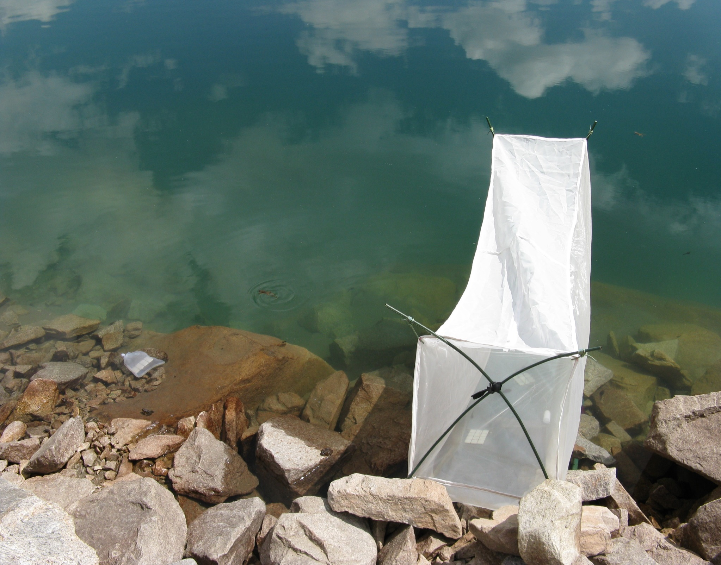

20 cm

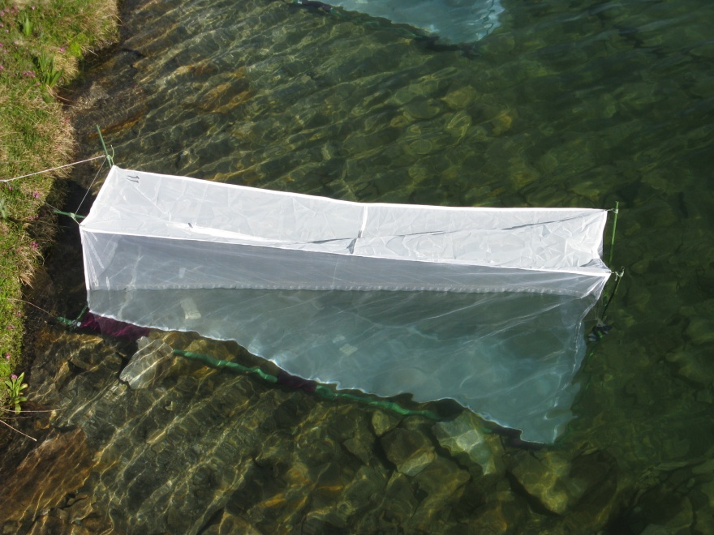

50 cm

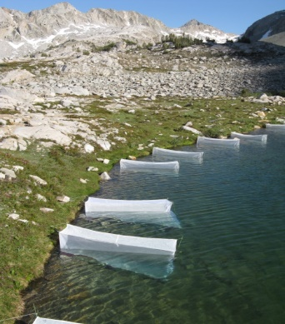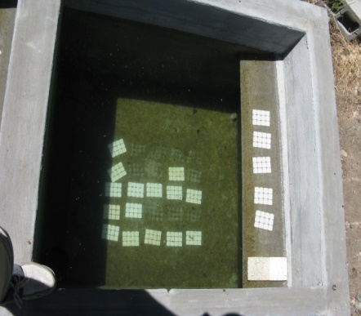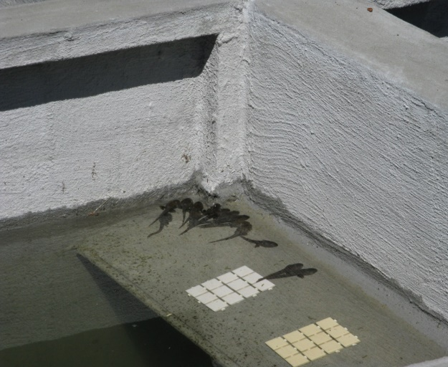

20 cm

*photo of me checking mesocosms, found in TomPhotos on external hard drive*

c

b

a

d

e

f

FIG. 1. a) *in situ* experimental mesh enclosure in LeConte lake, b) no consumer location-within-lake control tiles in bag of same mesh as enclosure and placed next to enclosure, c) Field enclosures in LeConte lake in Kings Canyon National Park, d) mesocosms located at Sierra Nevada Aquatic Research Laboratory in Mammoth Lakes, CA, e) view of experimental tiles and algal growth in one mesocosm, and f) tadpoles basking on shelf in a mesocosm.

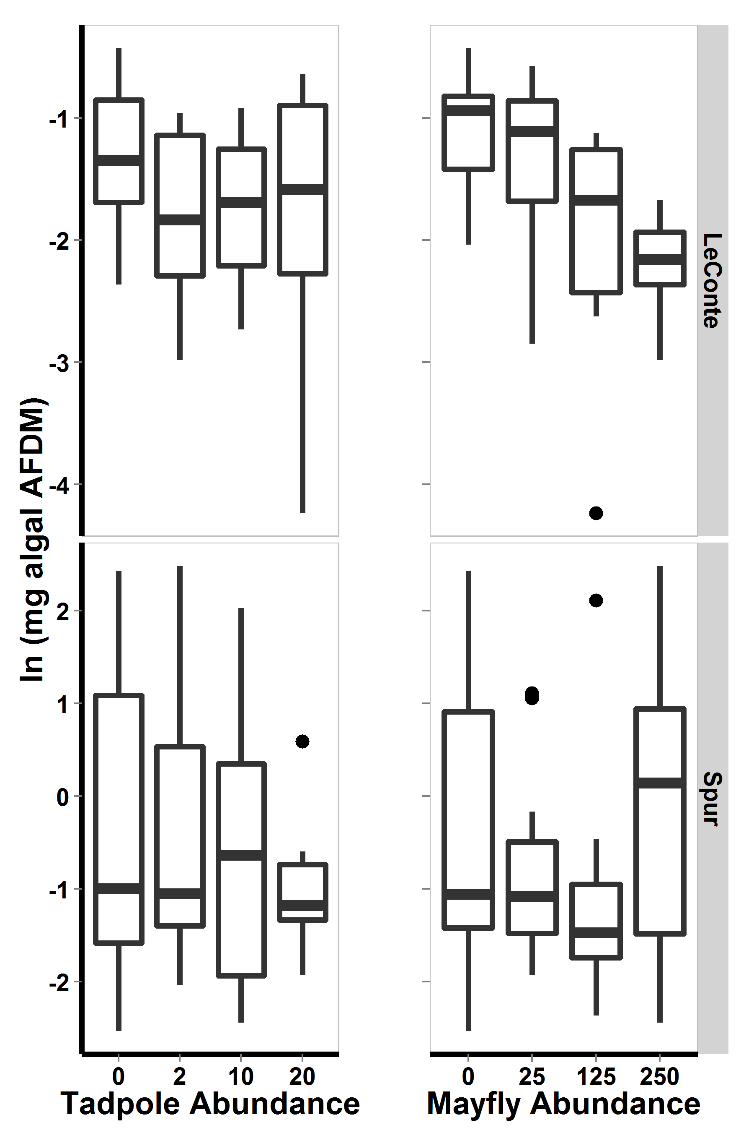

Figure 2. For 2009 field enclosure experiment, algal abundance with respect to lake and to each consumer. Bars show medians, boxes include 50% of the data, and whiskers include 95% of the data.

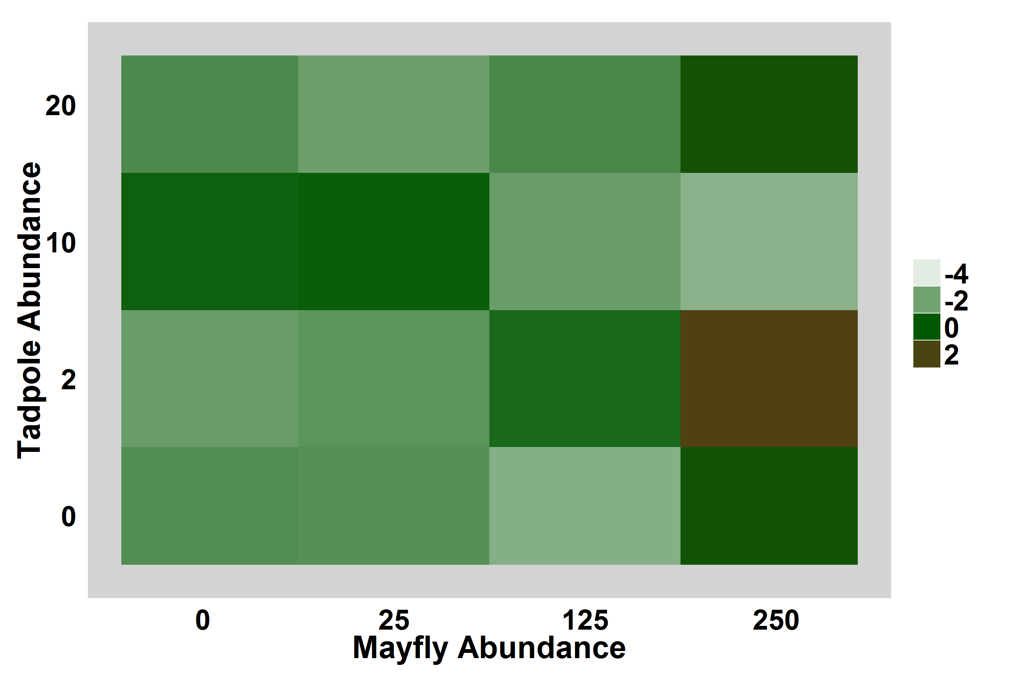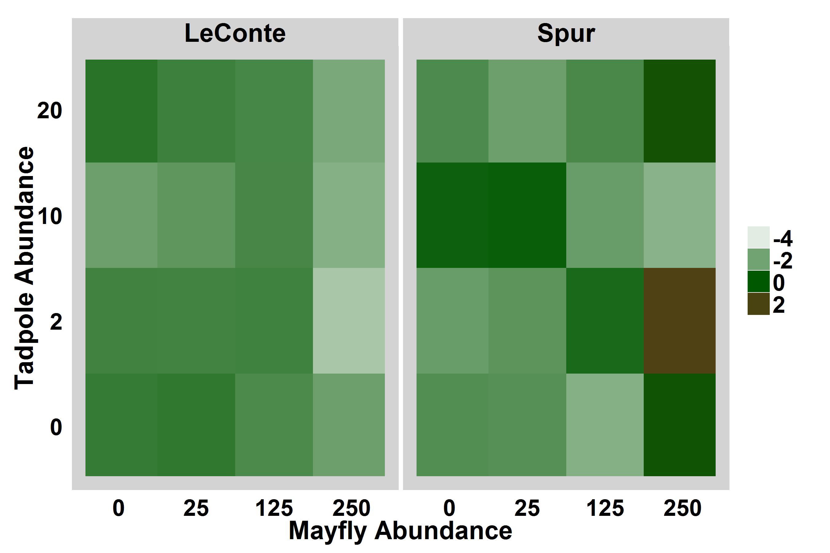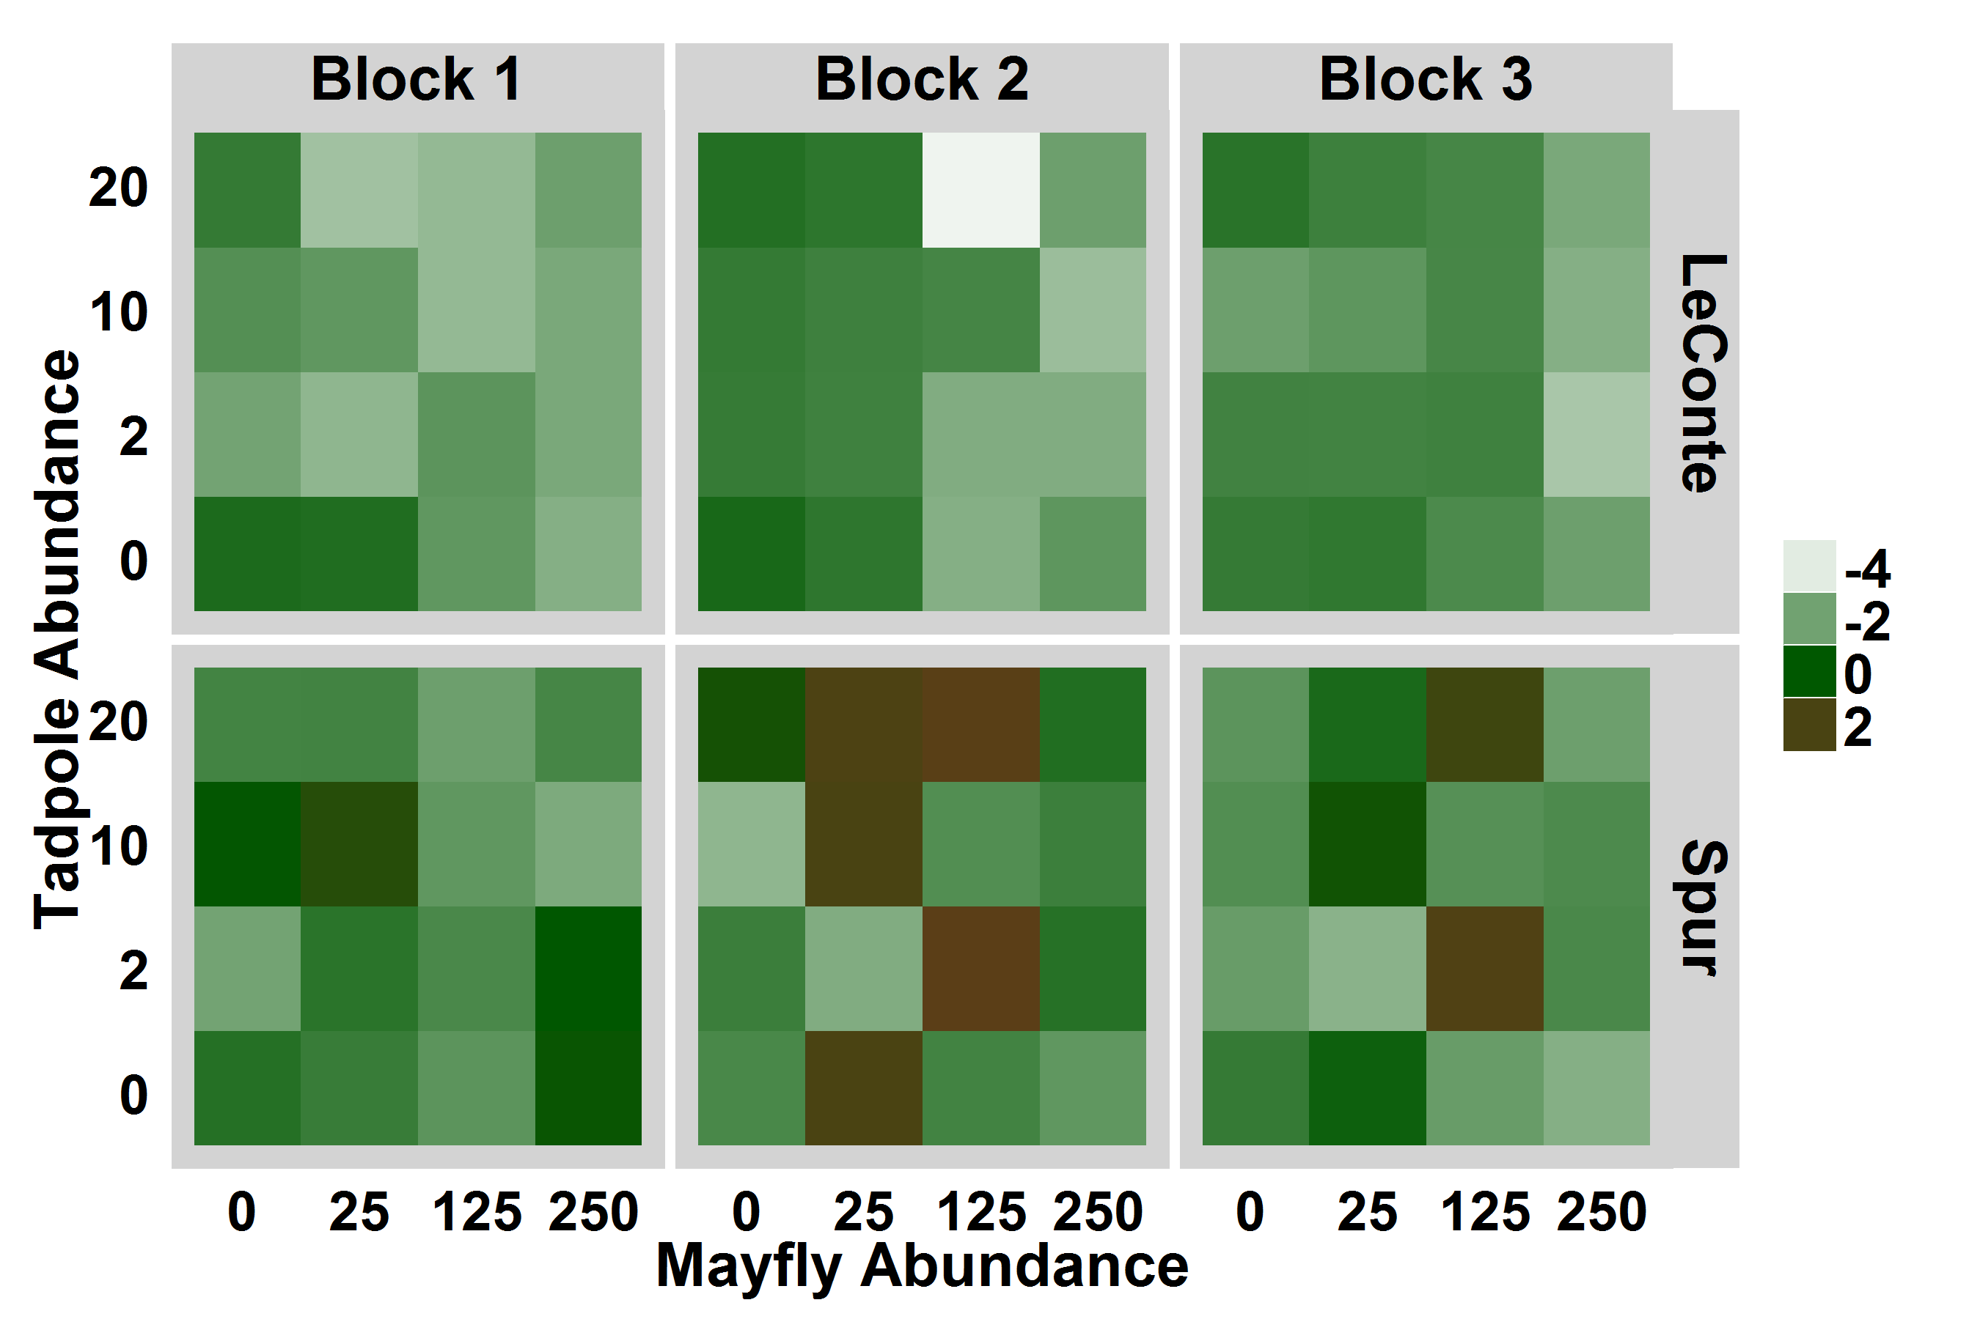

Figure 3. For 2009 field enclosure experiment, heat map displaying log-transformed algal abundance with respect to consumer densities and lake, averaged over experimental blocks. Brown indicates high algal abundance.

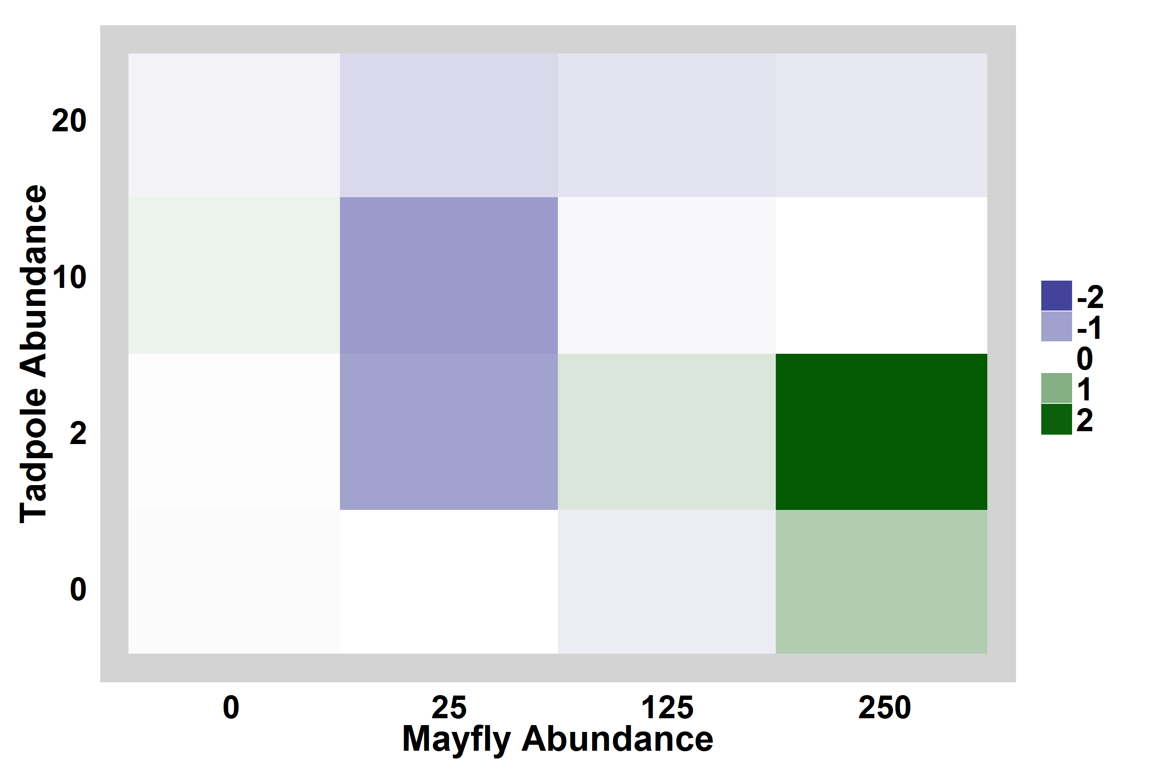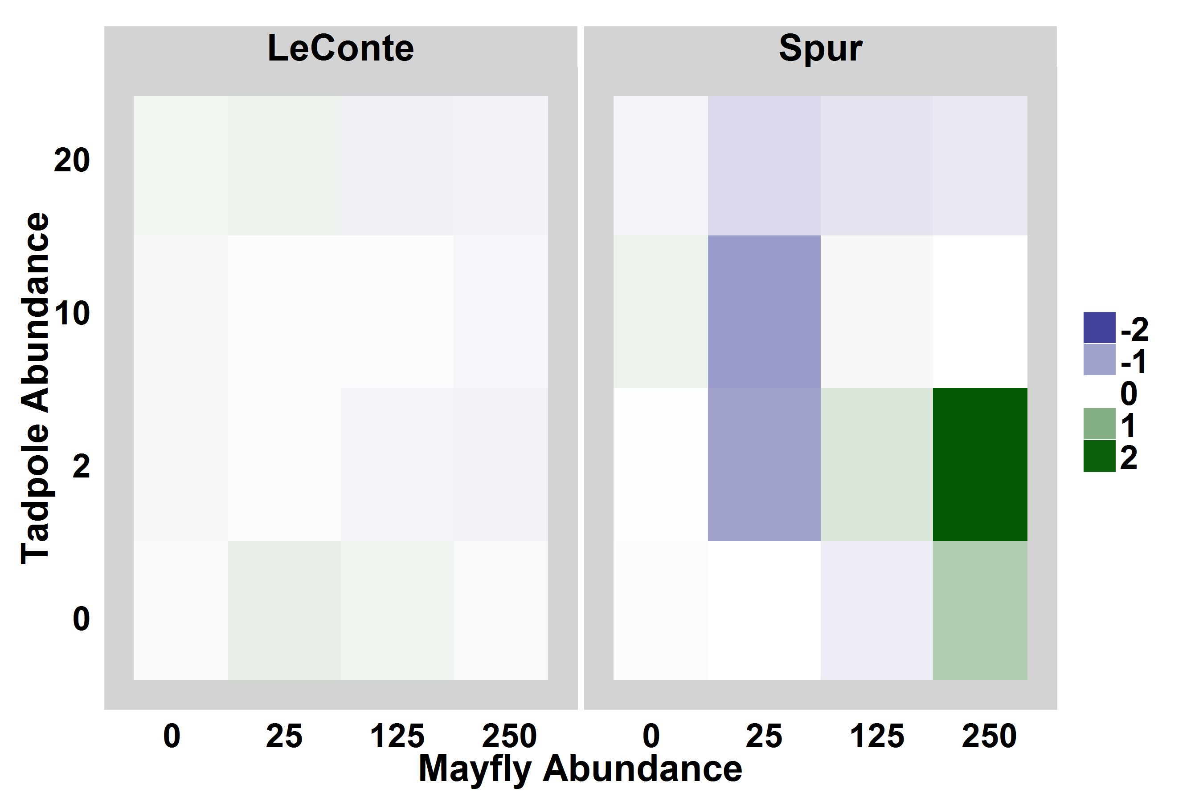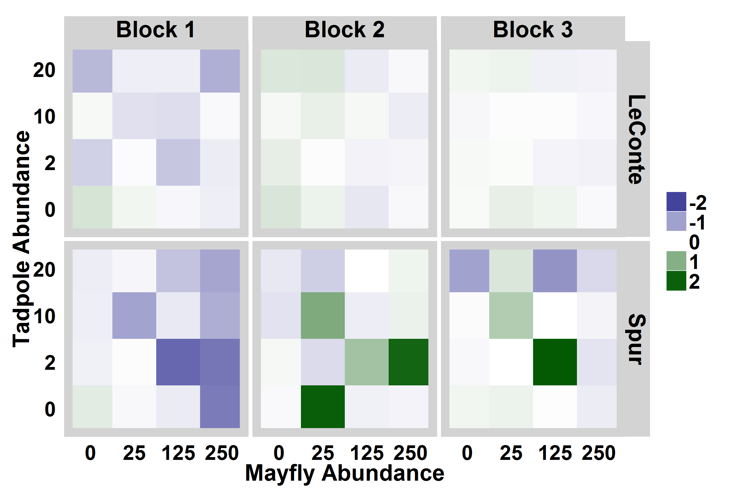

Figure 4. Heat maps showing algal abundance in each enclosure relative to location-within-lake controls. Bluer colors indicate that algal abundance was lower in the enclosure than in the control, i.e. consumers reduced algal abundance, while greener colors indicate that algal abundance was high in enclosures relative to controls. For display purposes, the relative algal abundance was log-modulus transformed.

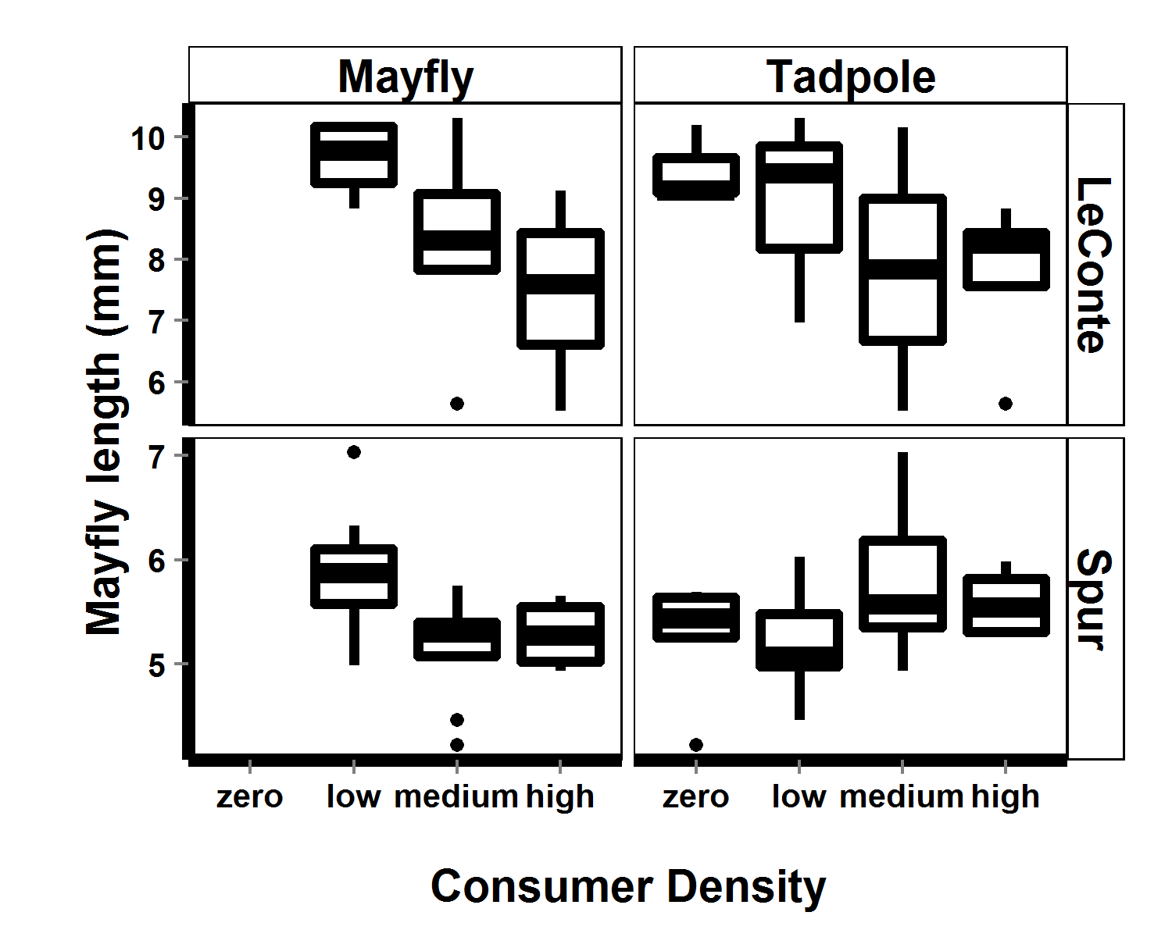

Figure 5. For 2009 field enclosures, mayfly lengths (mm) with respect to tadpole abundance and to mayfly abundance. Note difference in mayfly length scales between lakes.

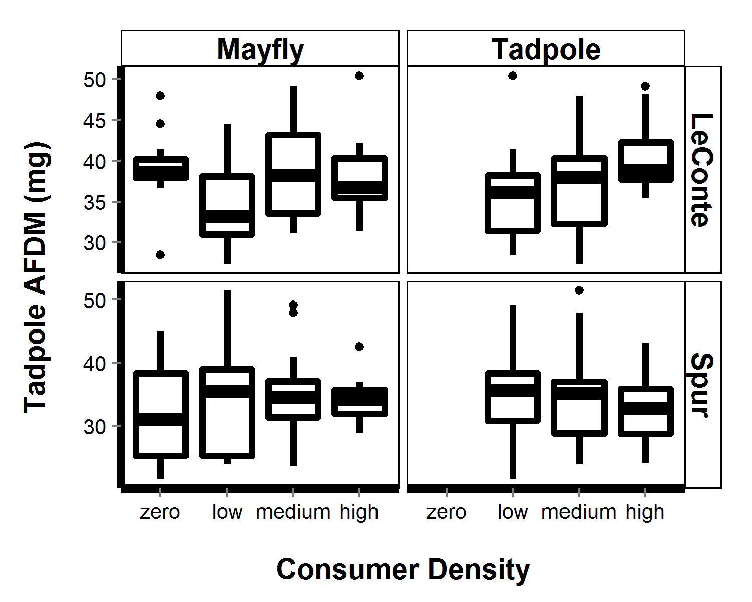

Figure 6. For field enclosures, estimated tadpole AFDM (mg, based on Gosner stage-AFDM regression) with respect to tadpole abundance (top) and mayfly abundance (bottom).

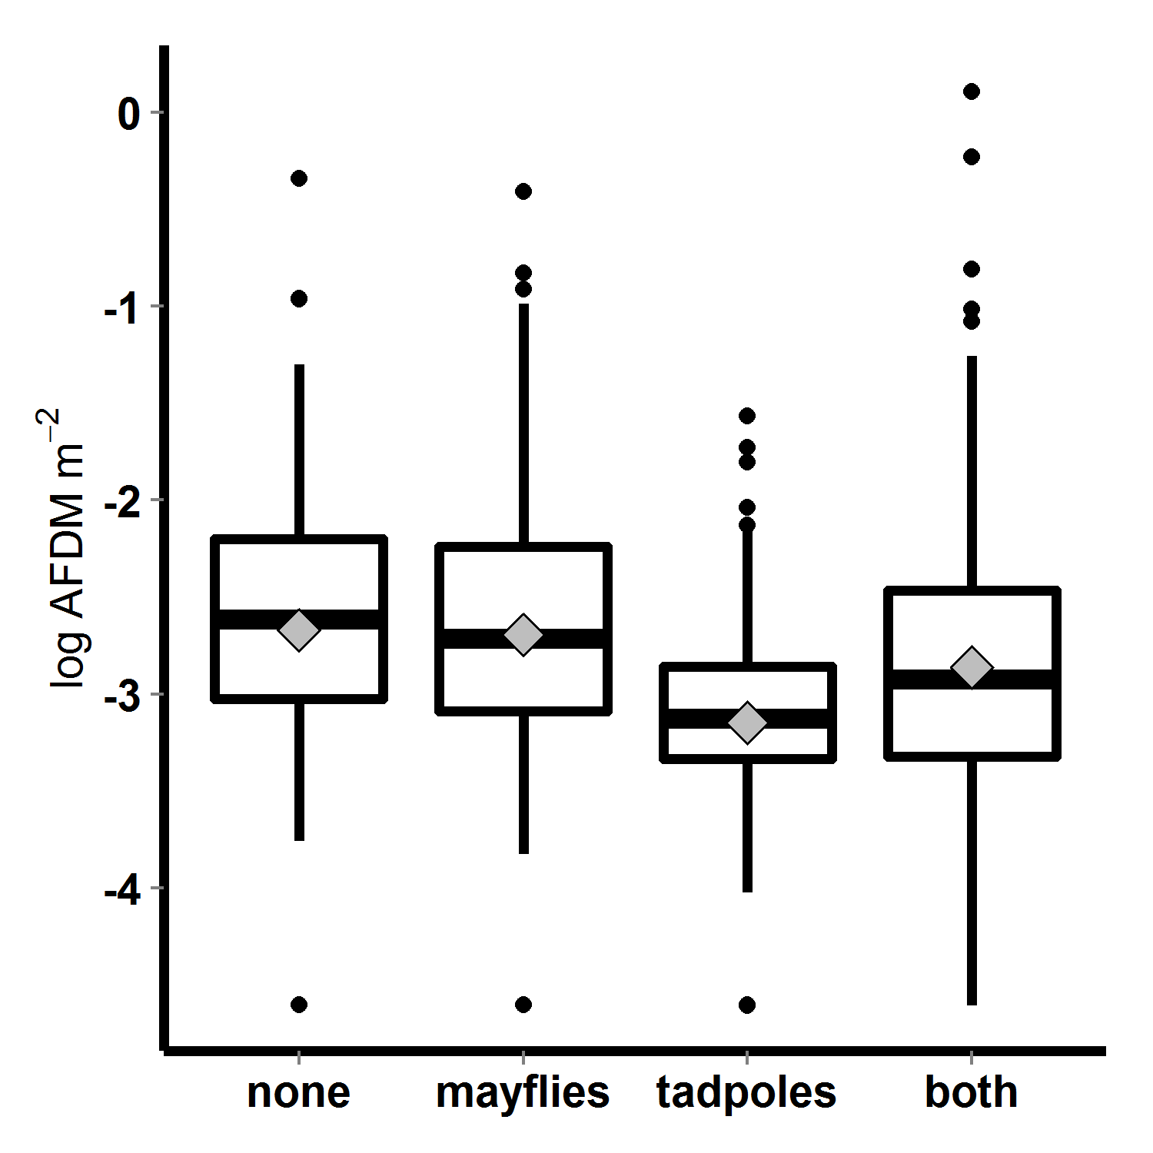

Figure 7. Algal abundance (log transformed AFDM) in 2010 mesocosms, with respect to tadpole and mayfly treatments; bars indicate medians, boxes contain 50% of data, whiskers contain 95% of the data, points are outliers, and diamonds indicate means.

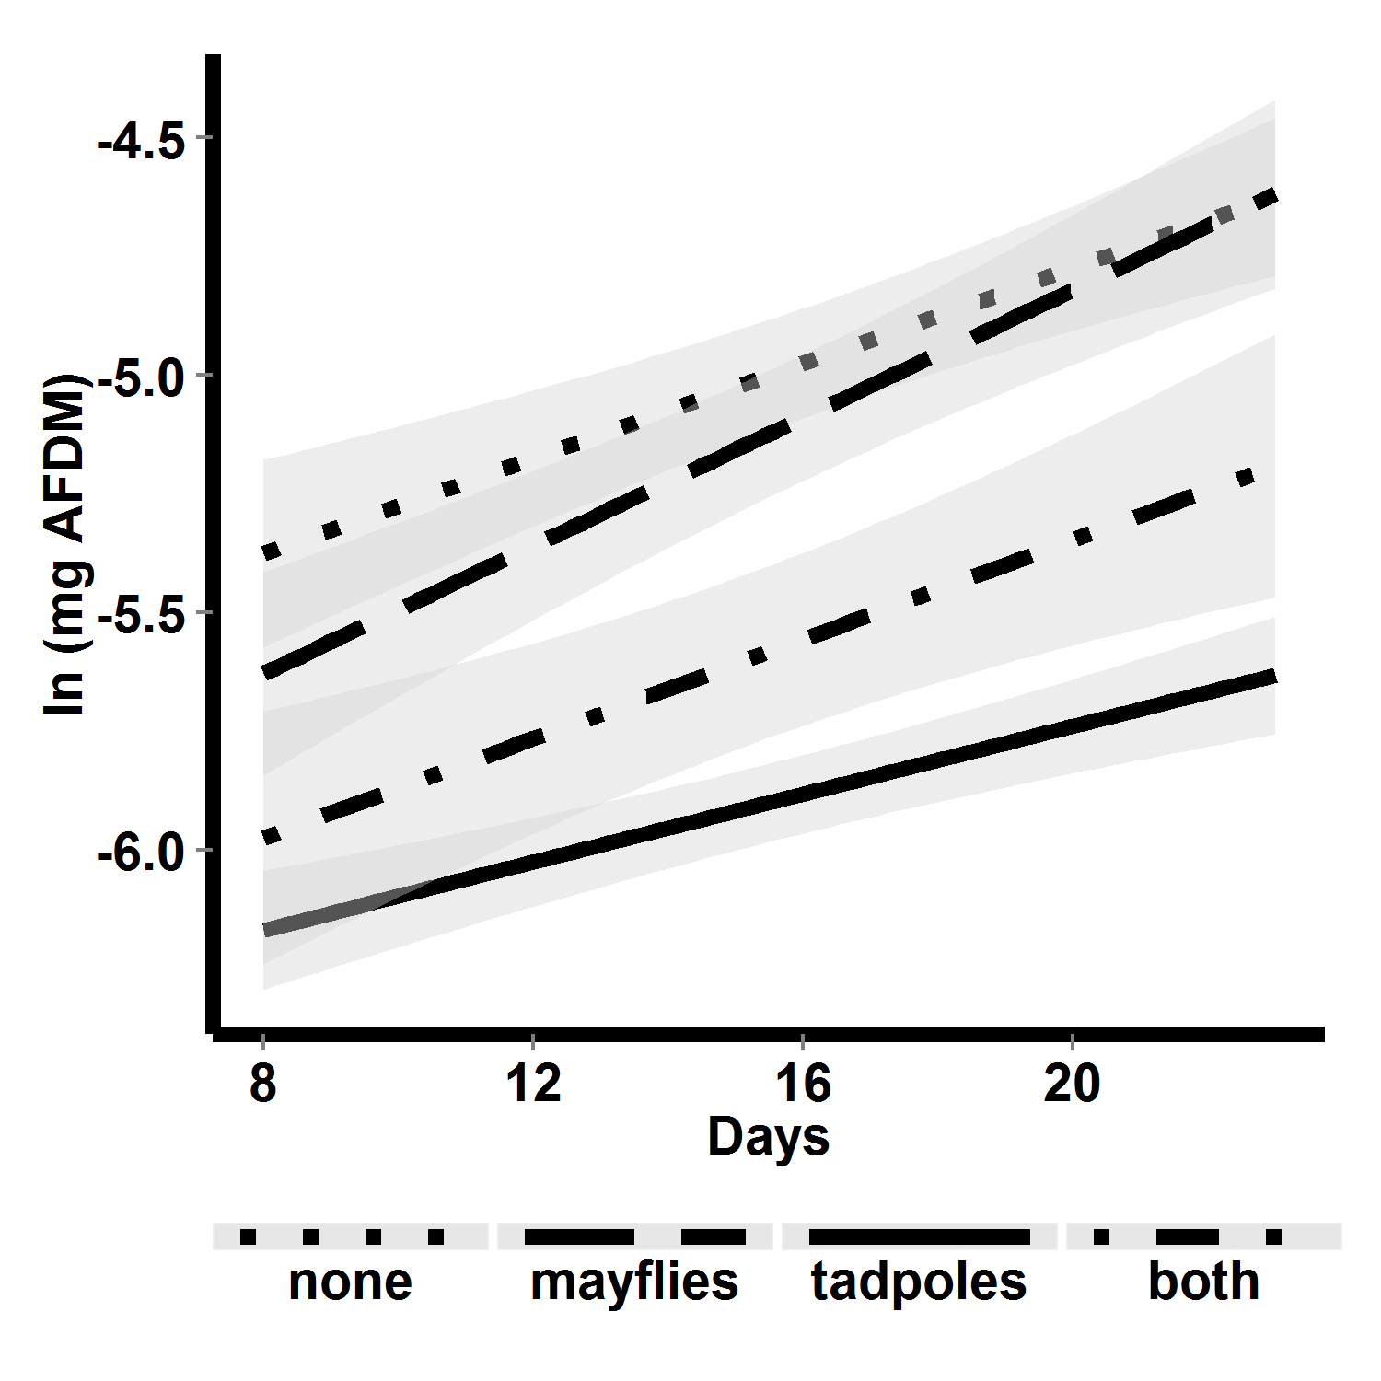

Figure 8. Algal abundance over time in 2010 mesocosms, with respect to consumer treatment. Lines are linear fits, and shaded areas are 95% confidence regions for those fits.

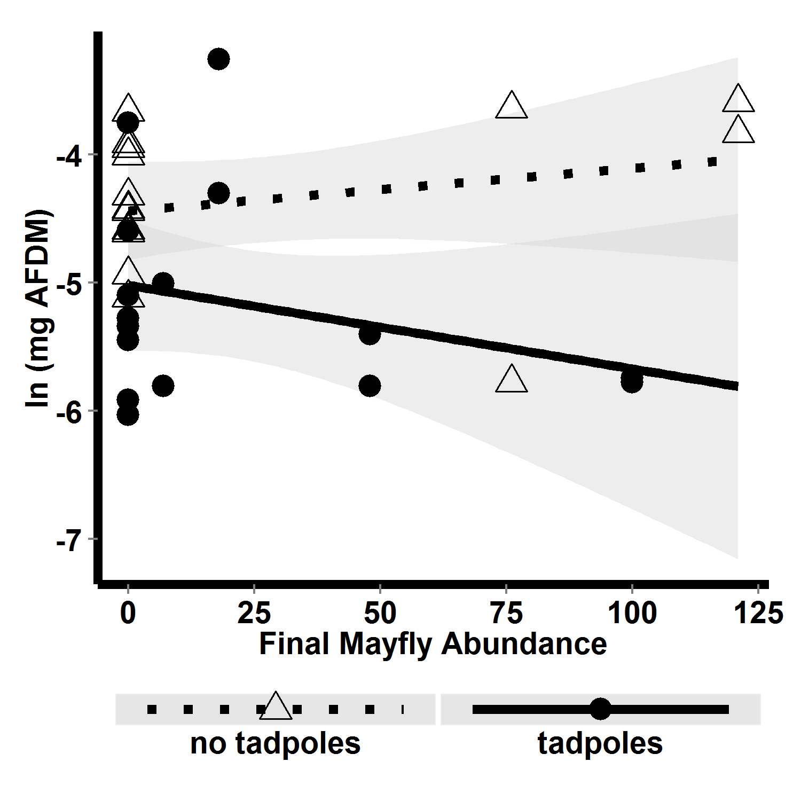

FIG. 7. Algal abundance with respect to interaction between final mayfly abundance and tadpole presence absence.